ENTERPRISE INTEGRATION ARCHITECTURE · REFERENCE GAZETTE
The Boomi Integration Patterns
A reference catalogue for HMRC-aligned enterprise integration via Boomi
VOL. I · PATTERNS P-101 – P-121 · SCOPE PROTOCOL BRIDGING · SYNC/ASYNC · EVENTS · RESILIENCE · COEXISTENCE

Executive Summary
This catalogue sets out sixteen integration patterns in active use, or recommended for adoption, across the Boomi integration layer in an HMRC-aligned enterprise landscape. Each pattern is documented to a consistent standard — intent, architecture diagram, technical specification, and implementation guidance — so that delivery teams, architects, and assurance reviewers can work from a single, agreed reference rather than re-deriving the same design decisions on every engagement.
The patterns are organised by integration style (synchronous, asynchronous, event-driven, batch, and resilience/governance) and are designed to be composed: several entries explicitly reference and build on one another, reflecting how they are actually combined in delivery.

Document Control
Field | Detail
Document | Boomi Integration Patterns — Reference Catalogue
Audience | Integration architects, delivery leads, technical assurance
Status | Draft for review
Owner | Integration Architecture Practice
Classification | Internal Use Only

How to Use This Catalogue
- Start from the situation, not the pattern name. Use the Pattern Selection Matrix to find the row that matches the integration problem at hand.
- Read the cited pattern in full before designing against it — the specification table and field notes capture decisions that are easy to get wrong on a first pass.
- Check for composition. Several patterns are designed to work together (e.g. P-111 composes P-101/P-102; P-104 relies on P-110 for delivery guarantees) — cross-references are called out in each entry's notes.
- Reference by code in design documents (e.g. "implements P-103") so reviewers can trace a design decision back to an agreed standard.

Contents
Executive Summary
Document Control
How to Use This Catalogue
Part One — Prescriptive Pattern Catalogue (P-101 to P-116)
P-101 · Mediation — SOAP-to-REST Facade over Legacy HMRC Services
P-102 · Direct Integration — Synchronous REST Direct Integration
P-103 · Decoupled Processing — Asynchronous Request–Reply with Correlation
P-104 · Event Distribution — Publish/Subscribe Event Distribution
P-105 · Coexistence — Boomi ⇄ WebMethods Coexistence Bridge
P-106 · Distributed Transaction — Saga Orchestration & Compensating Transactions
P-107 · Batch Exchange — File-Based Managed File Transfer (MFT)
P-108 · Load Levelling — Competing Consumers
P-109 · Payload Offload — Claim Check — Large Payload Offload
P-110 · Reliable Event Source — Change Data Capture + Outbox
P-111 · Aggregation Layer — API Gateway / Backend-for-Frontend
P-112 · Resilience Guardrail — Circuit Breaker & Bulkhead Isolation
P-113 · Domain Protection — Canonical Data Model / Anti-Corruption Layer
P-114 · Delivery Safety — Idempotent Receiver
P-115 · Push Notification — Webhook Push Notification
P-116 · Dynamic Routing — Content-Based Router & Scatter-Gather
P-117 · Audience Shaping — Experience API — Entitlement-Based Data Shaping
P-118 · Database Integration — Database Transactions Exposed as a REST API
P-119 · Database Integration — Direct Database Interaction
P-120 · Delivery Confirmation — Acknowledged Subscribe with Retry
P-121 · Delivery Assurance — Reliable Publish with Retry & Guaranteed Delivery
Pattern Selection Matrix
Part Two — As-Is Pattern Inventory
Publish Patterns (P1–P8)
Subscribe Patterns (S1–S6)
Direct Patterns (D1–D4)
Glossary of Terms
Document History

Part One — Prescriptive Pattern Catalogue (P-101 to P-116)
The patterns below define the standard this practice designs against. Each is documented to a consistent structure: intent, narrative description, architecture diagram, technical specification, and field notes drawn from delivery experience.

P-101 · Mediation — SOAP-to-REST Facade over Legacy HMRC Services
SYNCHRONOUS | PROTOCOL BRIDGING | LEGACY SOAP BACKEND
Use when a modern consumer (Salesforce, SAP S/4HANA, a citizen-facing portal) needs JSON/REST, but the system of record only exposes SOAP/XML — typical of long-lived case-management and taxpayer-record services.
Many of the systems that hold the most authoritative HMRC data were built in an era when SOAP and WSDL were the default integration contract, and replacing them outright is rarely realistic within the timeframe a modern programme needs. At the same time, every new consumer — a Salesforce case view, a citizen-facing portal, a mobile app — is built against REST and JSON as a matter of course, and expecting each of those teams to hand-roll their own SOAP client against a decades-old WSDL is both slow and a recurring source of defects. This pattern exists to absorb that mismatch in exactly one place rather than in every consumer that needs the data.
Boomi sits as a permanent facade in front of the legacy service: it terminates a clean, versioned REST contract on the consumer-facing side, and speaks the legacy SOAP dialect — envelopes, namespaces, WSDL bindings, fault structures — on the other. Crucially, the REST contract it exposes is designed as if the legacy system didn't have its historical quirks at all, so consumers get an interface that reflects how the data should be modelled today, not how it happened to be modelled when the backend was built. The facade becomes the long-term integration point even after the legacy backend is eventually replaced — only the implementation behind the contract needs to change.
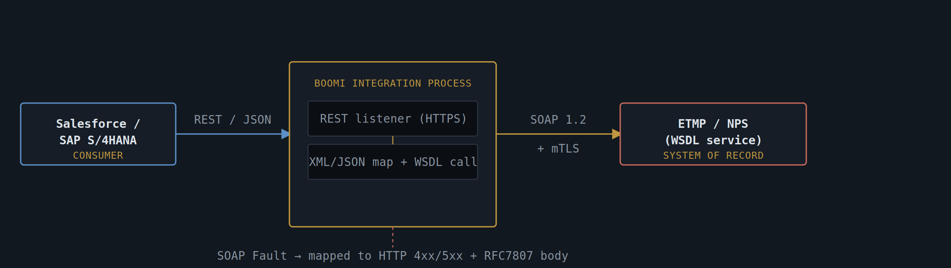
Fig. 1 — Boomi as a protocol-mediation facade between a REST consumer and a SOAP system of record

Specification
Trigger | Boomi REST Listener shape on a published HTTPS endpoint, behind an API gateway for auth/throttling.
Transform | Boomi Map + XML Profile generated from the legacy WSDL; JSON profile generated from an OpenAPI contract owned by the consumer team.
Backend call | Web Services Server/Client connector invoking the legacy SOAP operation; envelope built from the WSDL binding.
Security | Inbound: OAuth2 client-credentials at the gateway. Outbound to legacy: mTLS client certificate, rotated via Boomi's secure properties store.
Fault handling | SOAP <Fault> elements mapped to RFC 7807 problem+json responses; original fault code preserved in an extension field for traceability.
Idempotency | Consumer-supplied Idempotency-Key header cached for 24h to prevent duplicate submission to the legacy service on client retry.

Notes from the Field
- Treat the generated OpenAPI contract as the artefact of record, not the WSDL — it's what new consumers will integrate against for years after the legacy backend is eventually replaced.
- Where the legacy service has chunky, multi-call workflows, resist the urge to expose them 1:1 as REST; this is the moment to design the REST resource model the way it should have looked from the start.
- Log both the inbound REST payload and the outbound SOAP envelope (redacted) — fault correlation across the bridge is the single biggest support cost in this pattern.

P-102 · Direct Integration — Synchronous REST Direct Integration
SYNCHRONOUS | REQUEST/RESPONSE | IPAAS BROKERING
Use for real-time lookups and writes where the calling service must block on a response — eligibility checks, balance enquiries, validation calls — and both ends already speak REST.
Some interactions are genuinely synchronous by nature: a user is sitting in front of a screen waiting for an eligibility result, or one service needs to validate something before it can proceed with its own transaction. In these cases, decoupling the call into a queue or an event would only add latency and complexity without buying any real resilience benefit, because the caller has nothing useful to do until the answer arrives anyway. This pattern is the straightforward, brokered request/response model for exactly that situation — REST in, REST out, with Boomi doing routing, authentication, and light transformation in between.
The discipline in this pattern lives less in the happy path and more in how it behaves under stress. Because the caller's connection stays open for the full round trip, every millisecond of added latency in the broker is felt directly by the end user, and every backend slowdown risks cascading into the caller if timeouts and circuit breakers (see P-112) aren't configured deliberately. Boomi's role here is as much about protecting the caller from a misbehaving backend as it is about routing the request — fast, predictable failure is far preferable to a connection that hangs indefinitely waiting on a system that has quietly stopped responding.
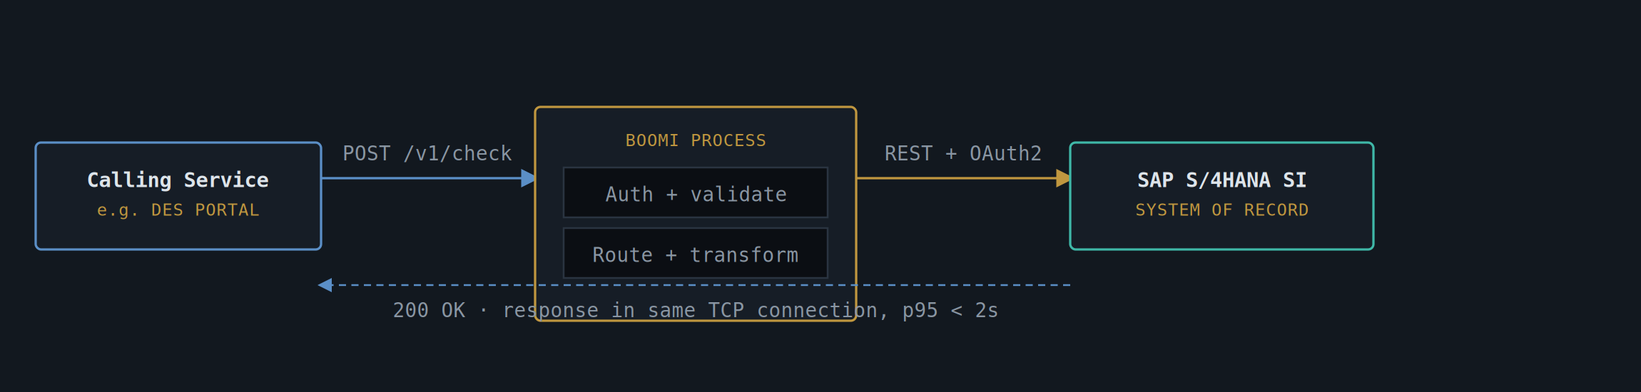
Fig. 2 — Boomi brokering a blocking call; caller holds the connection open for the full round trip

Specification
Trigger | Boomi REST Listener , low-latency runtime (Atom/Molecule sized for sub-2s SLA).
Routing | Decision + Route shapes for environment/tenant-based dispatch where one façade serves multiple backend instances.
Timeout strategy | Caller timeout set strictly shorter than gateway timeout, set shorter than backend timeout — prevents a slow backend producing a caller-side retry storm.
Resilience | Circuit breaker around the backend connector; on open circuit, return 503 with Retry-After rather than queuing silently.
Observability | Correlation ID generated at ingress, propagated as X-Correlation-Id , logged at every hop including the SAP SI gateway.

Notes from the Field
- This is the pattern people reach for by default — reserve it for genuinely synchronous needs. If the caller doesn't need the answer in the same interaction, P-103 is usually the better-behaved choice under load.
- Avoid burying a saga inside a "synchronous" call by chaining multiple backend invocations in one Boomi process — it just moves the long-running problem somewhere less visible.

P-103 · Decoupled Processing — Asynchronous Request–Reply with Correlation
ASYNCHRONOUS | CORRELATION ID | LONG-RUNNING CASE
Use where the backend operation is slow, batch-oriented, or itself asynchronous — case progression in DES/ChRIS, document-heavy submissions, anything that shouldn't hold a caller's connection open.
Plenty of HMRC-adjacent operations simply cannot complete within the lifetime of an HTTP connection — a case might need manual review, a document bundle might need scanning and validation, or the downstream system might itself process work in batches on its own schedule. Forcing a synchronous contract onto this kind of operation either means an unacceptably long-held connection, or it means lying to the caller with an artificially fast acknowledgement that doesn't reflect when the work is actually done. This pattern resolves that honestly: the caller is told immediately that their request has been accepted, and is given a reliable way to find out what happened once it actually has.
The correlation ID is the load-bearing element of the whole pattern — it is the thread that ties together a submission made at 9am with a result that might not exist until 4pm, possibly after several intermediate system hops. Boomi's job is to make that thread durable: persist the request, acknowledge it, queue the work, and make the eventual result retrievable by that same ID regardless of how many retries, requeues, or backend restarts happen in between. Done well, the caller experience is simple even though the underlying processing is not — submit, get a reference, check back (or get a callback) when ready.
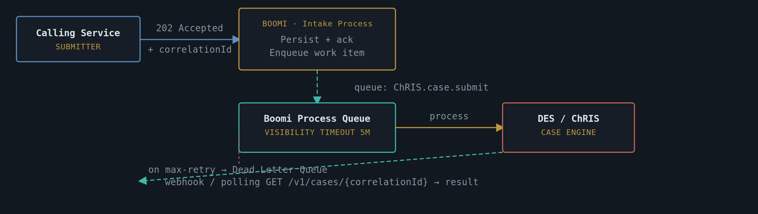
Fig. 3 — Decoupled intake/processing with correlation-based result retrieval and DLQ fallback

Specification
Acknowledgement | Caller receives 202 Accepted with a generated correlationId immediately — no wait on backend processing.
Result delivery | Either caller polls GET /v1/cases/{correlationId} , or Boomi pushes a webhook callback to a URL registered at submission time.
Queueing | Boomi Message Queue shapes (or a JMS/SQS-backed connector) with an explicit visibility timeout sized to the slowest expected backend step.
Failure handling | Bounded retry with exponential backoff; exhausted retries route to a Dead Letter Queue with full payload + failure reason for manual replay.
Compensation | If the case engine partially commits before failing, a compensating action (cancel/reverse) is triggered from the DLQ handler rather than left to manual reconciliation.

Notes from the Field
- The correlation ID is the contract — design it to be safe to log, safe to hand to a citizen-facing UI, and stable across retries of the same submission.
- Decide webhook-vs-polling per consumer, not globally: portal UIs tend to want polling (simpler infra), internal services tend to want webhooks (less chatter).

P-104 · Event Distribution — Publish/Subscribe Event Distribution
ASYNCHRONOUS | FAN-OUT | EVENT-DRIVEN
Use when one event needs to reach several independent consumers without the publisher knowing or caring who they are — a taxpayer-record change that interested systems each react to differently.
A taxpayer record changing status, a payment landing, a case closing — these are facts that matter to several different systems at once, each for its own reason: one needs to update an audit trail, another needs to trigger a downstream calculation, a third needs to refresh a CRM view. Building point-to-point integrations for each of these relationships means the publishing system ends up knowing, and depending on, every consumer that currently cares — and every new consumer added later requires a change request against a system that, by rights, shouldn't need to know they exist. This pattern breaks that coupling by introducing a topic: the publisher announces a fact once, and anyone interested subscribes independently.
Boomi's role is as the normaliser and relay, not the broker itself — it takes the publishing system's internal representation of an event and turns it into a versioned, business-meaningful fact ("taxpayer record updated") that has nothing to do with the publisher's database schema. From there, the underlying topic technology (Kafka, SNS/SQS fan-out, or an internal bus) handles distribution, and each subscriber owns its own consumption, its own retry behaviour, and its own failure handling. A slow or broken subscriber is a problem for that subscriber to fix — it should never be visible to the publisher, and it should never block delivery to anyone else.
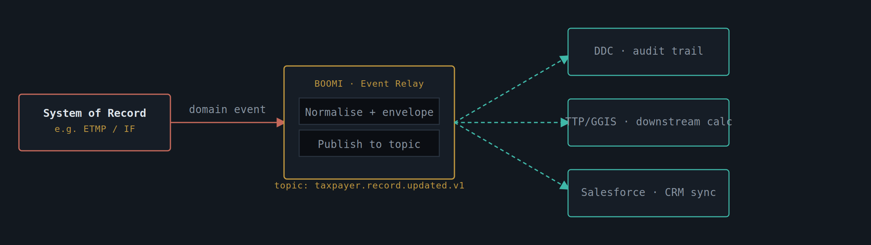
Fig. 4 — Single domain event normalised and fanned out to independent subscribers

Specification
Publisher contract | Versioned event schema ( taxpayer.record.updated.v1 ) — additive changes only; breaking changes ship as a new version, old version kept live until subscribers migrate.
Topic technology | Boomi publishing to a broker topic (e.g. Kafka, SQS/SNS fan-out, or an internal Enterprise Message Bus) — Boomi itself is the normaliser, not the broker.
Subscriber independence | Each consumer owns its own subscription, its own retry/backoff, and its own dead-letter handling; a slow or failing subscriber must never block the others.
Delivery guarantee | At-least-once delivery assumed; subscribers design for idempotent processing keyed on event ID, not on receiving each event exactly once.
Ordering | Per-entity ordering only (partition/key by taxpayer reference) — no global ordering guarantee across entities.

Notes from the Field
- Resist letting the publisher's internal data model leak into the event schema — the event should describe a business fact ("record updated"), not a database row.
- New subscribers should be addable without a change request against the publisher. If adding one requires touching the Boomi process, the fan-out isn't actually decoupled yet.

P-105 · Coexistence — Boomi ⇄ WebMethods Coexistence Bridge
MIGRATION | BRIDGED SYNC | LEGACY ORCHESTRATION
Use during the multi-year period where WebMethods still owns legacy orchestration and Boomi is the platform of record for new cloud/SaaS integration — the realistic middle state, not a one-weekend cutover.
Replatforming an estate's integration layer is never an event — it's a multi-year condition, and most of that time is spent with both the old and new platforms genuinely in production at once, each legitimately owning part of the landscape. Pretending otherwise, by trying to force a single cutover weekend or by quietly building new integrations on the old platform "just for now" because it's faster, tends to produce the worst of both worlds: a migration that drags on indefinitely with no clear architectural boundary to show for it. This pattern names that middle state explicitly and gives it a durable structure, rather than treating it as an embarrassment to be hidden.
The rule is simple to state and disciplined to hold to: every new piece of integration work, without exception, is built in Boomi from day one, while WebMethods continues to run the flows it already owns until each is individually retired. The bridge between the two platforms is a plain HTTP/REST interface secured with mTLS and OAuth2 — never a shared database table or a file drop "to save time," both of which have a habit of outliving their intended lifespan by years. Migrating an individual flow is a deliberate, reversible event: re-platform it, run it in parallel against the legacy version for an agreed burn-in period, and only switch the legacy version off once the two have demonstrably matched.
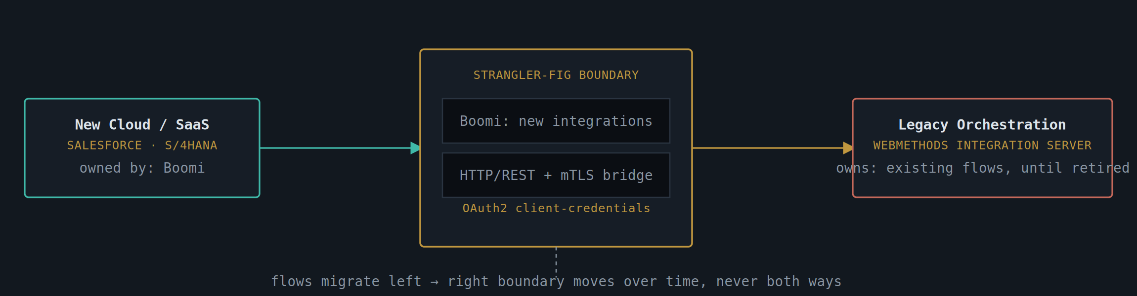
Fig. 5 — The bridge as a moving boundary: new build lands in Boomi, legacy flows retire from WebMethods one at a time

Specification
Ownership split | WebMethods retains existing orchestration flows as-is. Boomi owns every new integration and every cloud/SaaS endpoint from day one.
Bridge protocol | HTTP/REST between the two platforms, secured with mTLS for service identity and OAuth2 client-credentials for authorisation — no shared database, no file-drop coupling.
Migration unit | One WebMethods flow at a time, re-platformed to Boomi and cut over behind a feature flag at the gateway — never a "big bang" replatform.
Rollback | Gateway routing flag allows instant revert to the WebMethods flow if the Boomi replacement misbehaves in production.
Decommission gate | A WebMethods flow is only switched off once its Boomi replacement has run in shadow/parallel for an agreed burn-in period with matching output.

Notes from the Field
- The boundary is the architecture — document it explicitly per release, including which flows are still WebMethods-owned, so nobody builds new logic on the wrong side of it by accident.
- Avoid bridging through a shared staging table or file share "just for now" — it always outlives "now" and becomes the hardest thing to unpick later.

P-106 · Distributed Transaction — Saga Orchestration & Compensating Transactions
ASYNCHRONOUS | MULTI-STEP | CROSS-SYSTEM WRITE
Use when a single business action spans several systems that each commit locally — there is no distributed transaction across ETMP, SAP, and Salesforce, so consistency has to be engineered as a sequence of steps with explicit undo actions.
A single business action — registering a new case, for instance — can easily require a reservation in one system, a record update in a second, and a notification to a third, and there is no realistic way to wrap all three in one atomic database transaction across systems that were never designed to share one. If the third step fails after the first two have already committed, the estate is left in a state that no individual system recognises as wrong, because each one only sees its own piece. Left unmanaged, this becomes the quiet source of "data doesn't match" tickets that take days of manual reconciliation to untangle.
A saga makes that risk visible and manageable by treating the multi-system action as an explicit sequence with a memory of its own progress. Every step that changes state somewhere is paired, from the outset, with a compensating action that can undo it — a reservation gets released, an update gets reversed — and Boomi's orchestrator tracks exactly which steps have completed so that a failure partway through triggers compensation for precisely the steps that need undoing, in reverse order. The result isn't a perfect illusion of a single transaction, but it is a known, auditable, and recoverable process rather than a silent inconsistency waiting to be discovered later.
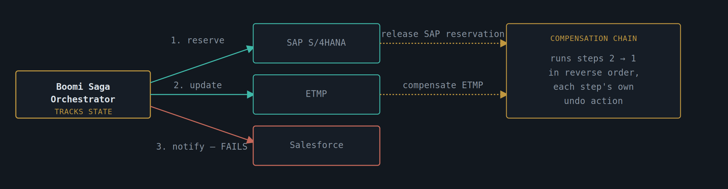
Fig. 6 — Orchestrated saga: step 3 fails, orchestrator walks the compensation chain backwards

Specification
Orchestration style | Centrally orchestrated in Boomi (a single process holds saga state) rather than choreographed via events — easier to reason about and audit for a regulated domain.
Step contract | Every step exposes both a forward action and a named compensating action; a step with no sensible undo (e.g. an irreversible notification) is moved to the end of the sequence.
State store | Saga state (which steps completed, which compensations ran) persisted outside the Boomi runtime so a restart can resume or compensate a saga left mid-flight.
Idempotency | Both forward and compensating actions are idempotent — a saga may retry a step or its compensation more than once after a crash.
Visibility | Saga status exposed as a queryable resource ( GET /v1/sagas/{id} ) for support teams to see exactly where a stuck cross-system update is.

Notes from the Field
- Write the compensating action at the same time as the forward action, not as an afterthought once something has already failed in production.
- Keep sagas short — three to five steps. A saga that grows past that is usually a sign the business process itself needs decomposing, not the integration.

P-107 · Batch Exchange — File-Based Managed File Transfer (MFT)
BATCH | SCHEDULED | BULK RECONCILIATION
Use for high-volume, scheduled bulk exchange where per-record APIs would be wasteful or simply don't exist — overnight reconciliation files, bulk uploads from third-party providers, statutory reporting extracts.
Not every integration need is record-by-record. Reconciliation runs, statutory extracts, and bulk uploads from external providers are naturally batch in shape — tens or hundreds of thousands of rows that need to move together, on a schedule, often to or from a system that has never exposed an API and realistically never will. Building a per-record interface for this kind of exchange would mean an enormous number of small calls for no real benefit, when a single well-validated file does the job more simply and matches how the source and target systems already think about the data.
What makes this pattern more than "just SFTP" is the discipline wrapped around the transfer. Every file is checked on arrival — checksum verified, expected row count confirmed — before a single record is processed, so a partial or corrupted transfer is caught immediately rather than silently loading bad data. Validation then happens at the row level rather than the file level: a handful of malformed records are quarantined with a clear exception report, while the rest of the file proceeds, rather than the entire night's batch being rejected over a handful of bad rows. Boomi's scheduling, encryption, and reconciliation summary turn what could be a fragile, manually-watched process into something an operations team can trust to run unattended.
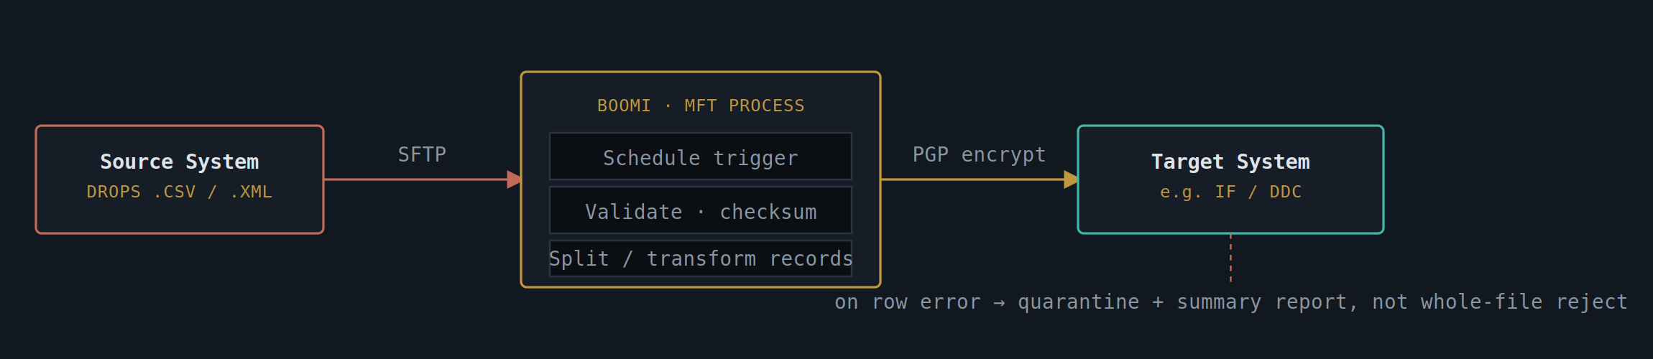
Fig. 7 — Scheduled SFTP batch pickup, validated and transformed, encrypted on the way out

Specification
Trigger | Boomi schedule (e.g. nightly 02:00) or file-arrival listener on an SFTP/AS2 endpoint, not a manual kick-off.
Integrity | Checksum (SHA-256) and expected row-count header validated before processing; mismatch halts the run rather than partially loading.
Security | PGP encryption at rest in transit, SFTP over key-based auth — no plaintext files cross a network boundary.
Error granularity | Row-level validation; bad rows quarantined with a per-file exception report rather than failing the entire batch.
Reconciliation | Boomi emits a summary record (rows in / rows processed / rows quarantined) consumed by an ops dashboard for same-day reconciliation.

Notes from the Field
- Treat the file naming and folder convention as part of the contract — date-stamping, "done" markers, and archive folders all need a written-down standard, or batch timing bugs become very hard to diagnose.
- If volumes shrink and latency expectations rise over time, this is the pattern most likely to be replaced by P-104 pub/sub later — design the target-side data model so that migration is additive.

P-108 · Load Levelling — Competing Consumers
ASYNCHRONOUS | HORIZONTAL SCALE | THROTTLING
Use when work arrives in spikes faster than a downstream system can absorb — a single queue, multiple worker instances pulling from it, so the backend sees a steady, controlled rate regardless of the inbound burst.
Demand on an integration rarely arrives at a constant rate. A campaign, a deadline, or a scheduled bulk trigger can produce a surge of work many times the normal volume in a short window, and if every one of those requests is forwarded straight through to the backend the moment it arrives, the backend — or a third-party API with its own rate limits — is simply going to fail under the load. The temptation is to try to make the backend faster; the more reliable fix is to decouple the rate at which work arrives from the rate at which it is processed.
This pattern does that with a single shared queue and a pool of Boomi workers competing to pull messages off it. The burst lands in the queue almost instantly — accepting work is cheap — while the workers drain it at a controlled, sustainable pace that the backend can actually handle, scaling the worker count up or down based on how deep the backlog has grown. The trade-off, made deliberately rather than by accident, is that ordering across messages is no longer guaranteed; where a subset of messages genuinely must stay in order, they're partitioned by a key so related messages always land on the same worker, while everything else benefits from the parallelism.
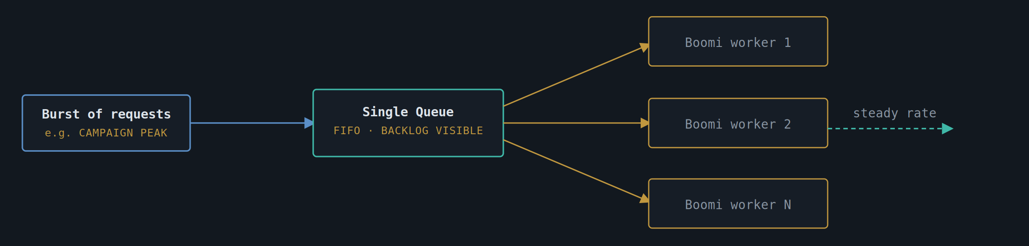
Fig. 8 — Many workers competing for messages off one queue, smoothing a burst into a steady backend rate

Specification
Queue semantics | One logical queue, message visibility timeout set so a worker that crashes mid-processing releases the message back for another worker to pick up.
Worker scaling | Boomi Atom/Molecule instance count scales with backlog depth — a queue-depth metric drives auto-scaling rather than a fixed worker count.
Ordering trade-off | No cross-message ordering guarantee by design; if order matters for a subset of messages, partition by key so related messages land on the same worker.
Poison messages | A message that fails processing N times moves to a dead-letter queue rather than being retried indefinitely and blocking its worker.

Notes from the Field
- This pattern absorbs the spike — it does not, by itself, speed up the slowest downstream system. Pair it with a rate limit on the outbound side if the true constraint is a third party's API quota.
- Distinguish this clearly from P-104 pub/sub in any architecture review: here, each message is consumed once by exactly one worker; in pub/sub, the same event reaches every subscriber.

P-109 · Payload Offload — Claim Check — Large Payload Offload
LARGE PAYLOAD | DOCUMENT-HEAVY | EVIDENCE / ATTACHMENTS
Use when a message would otherwise carry a large attachment (scanned evidence, a multi-MB submission bundle) through a broker or queue that is sized for small, fast messages — move the bulk, pass a reference.
Message brokers and queues are built around the assumption that messages are small — kilobytes, not megabytes — and that assumption underpins their throughput, their replay behaviour, and often their pricing. A scanned evidence pack or a multi-megabyte submission bundle breaks that assumption badly if it's pushed through the broker as the message payload itself: it slows every consumer that has to read past it, it bloats storage that was never sized for it, and it makes the broker's own operational characteristics far harder to reason about. The instinct to "just inline it, it's not that big" is exactly how message size limits get quietly worked around, one exception at a time, until the broker is carrying a workload it was never designed for.
The fix is to separate where the bulk lives from what travels through the messaging layer. The large object goes to an object store sized and managed for exactly that purpose, and the message that flows through Boomi and the broker carries only a small, stable reference to it — typically a URI plus a content hash. Downstream consumers retrieve the actual content only when they genuinely need it, often much later than when the message itself was processed, and access to that content goes through its own authorisation check so that a leaked message reference is never equivalent to a leaked document.
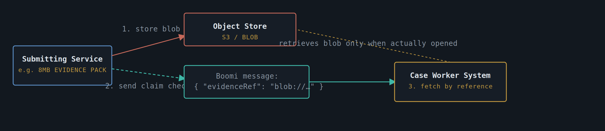
Fig. 9 — The bulky payload travels once to object storage; every downstream hop carries only a reference

Specification
Store | Object/blob store (S3-compatible or an internal document store) sized and lifecycle-managed independently of the messaging layer.
Reference | Message carries a stable reference (URI + content hash), never the bytes — keeps queue/broker messages small and fast regardless of attachment size.
Access control | Reference resolution requires its own authorisation check — a leaked message must not equal a leaked document.
Lifecycle | Retention policy on the blob store matches the case-retention policy, not the message TTL — the two lifecycles are independent and must both be set deliberately.
Cleanup | Orphan-blob sweep for cases where the referencing message was processed but the case was later deleted, to avoid silent storage growth.

Notes from the Field
- Decide content-hash verification on read, not just on write — it catches both corruption and tampering, and is cheap compared to the cost of acting on a wrong document.
- Don't let "just inline it, it's not that big" creep in for one consumer — message size limits exist for a reason and the exception always gets copied elsewhere.

P-110 · Reliable Event Source — Change Data Capture + Outbox
ASYNCHRONOUS | DUAL-WRITE AVOIDANCE | CQRS-ADJACENT
Use when a system must update its own database and publish an event about that update, and the two absolutely cannot fall out of step — the classic "dual write" failure that pub/sub alone (P-104) does not solve on its own.
The pub/sub pattern (P-104) describes how an event reaches its subscribers reliably once it has been published — but it quietly assumes the event was published in the first place, every single time the underlying data actually changed. In practice, a service that updates its database and then makes a separate call to publish an event about that update is exposed to a subtle but serious failure mode: the database write succeeds, the process crashes or the network call fails before the event goes out, and now the data has changed but nobody downstream was ever told. This "dual write" problem is one of the most common causes of silent, hard-to-detect data drift between systems that are supposed to be kept in sync.
The outbox pattern closes that gap by making the event itself part of the same local transaction as the data change — a row is written to an outbox table in the same database commit that updates the business data, so the two either both happen or neither does, with no window in between where one occurred without the other. Boomi then acts purely as a relay: it polls or tails that outbox table, publishes each unsent row to the same event topic used by P-104, and marks it dispatched. Because the relay itself can crash and resume without losing track of what's been sent, the overall guarantee is at-least-once delivery from a source that is itself guaranteed never to silently miss an event — which is exactly what makes the pub/sub fan-out further downstream something consumers can actually rely on.
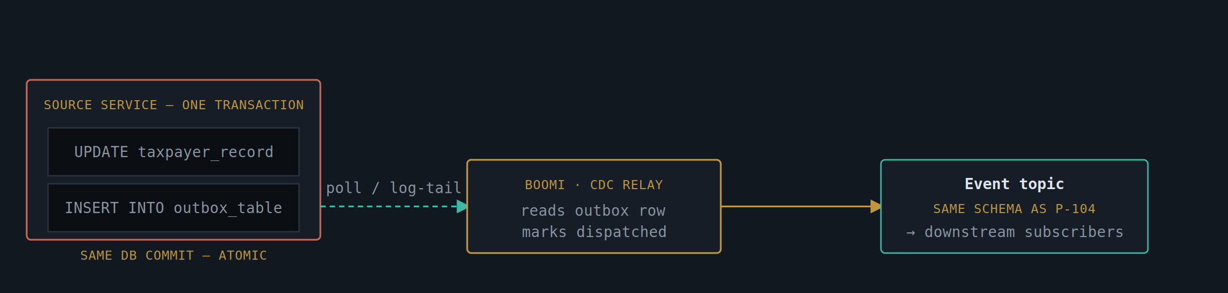
Fig. 10 — Database write and outbox write commit atomically together; Boomi relays the outbox, never writing the event directly from application code

Specification
Atomicity | The business-data write and the outbox-row write happen in the same local database transaction — never as two separate calls from application code.
Relay | Boomi polls the outbox table (or tails a database change log) on a short interval, publishes each unsent row, then marks it dispatched.
Delivery guarantee | At-least-once by construction — a crash between publish and mark-dispatched simply republishes; downstream consumers must already be idempotent, as in P-104.
Ordering | Outbox rows relayed in insertion order per source row key, preserving per-entity event order even though the relay itself runs on a poll loop.
Cleanup | Dispatched rows archived/purged on a retention schedule — the outbox table is a relay buffer, not a permanent event log.

Notes from the Field
- This is the pattern that actually makes P-104 trustworthy at the publishing end — pub/sub fan-out is only as reliable as the guarantee that an event always fires when the data change it describes actually happened.
- Resist the temptation to skip the outbox table "because the database has triggers anyway" — triggers calling out to Boomi directly reintroduce the same dual-write risk this pattern exists to remove.

P-111 · Aggregation Layer — API Gateway / Backend-for-Frontend
SYNCHRONOUS | FAN-IN | CHANNEL-SPECIFIC
Use when a single front-end screen needs data assembled from several backend systems in one round trip — a case summary that pulls taxpayer details, payment status, and case history in parallel rather than making the client call three APIs.
A case summary screen rarely maps cleanly onto a single backend system; it typically needs a taxpayer's core details from one system, payment status from another, and case history from a third. Leaving the client — a browser, a mobile app — to make all three calls itself and stitch the results together pushes integration complexity into exactly the place least equipped to handle it: every UI has to know which backends to call, how to handle each one failing independently, and how to reconcile timing differences between three separate round trips. As the number of screens and backends grows, that logic multiplies and starts to diverge between clients in ways that become hard to maintain.
This pattern moves that composition into a single Boomi-hosted endpoint shaped around what the screen actually needs, rather than around any one backend's data model — a genuine backend-for-frontend rather than a generic, one-size-fits-all aggregator. Internally, the calls to each backend happen in parallel wherever they're independent of each other, and the response is assembled once on the server side. Just as importantly, a single slow or failing backend — case history being temporarily unavailable, say — degrades only that section of the response rather than failing the whole screen, because the least important piece of data should never be allowed to block the most important.
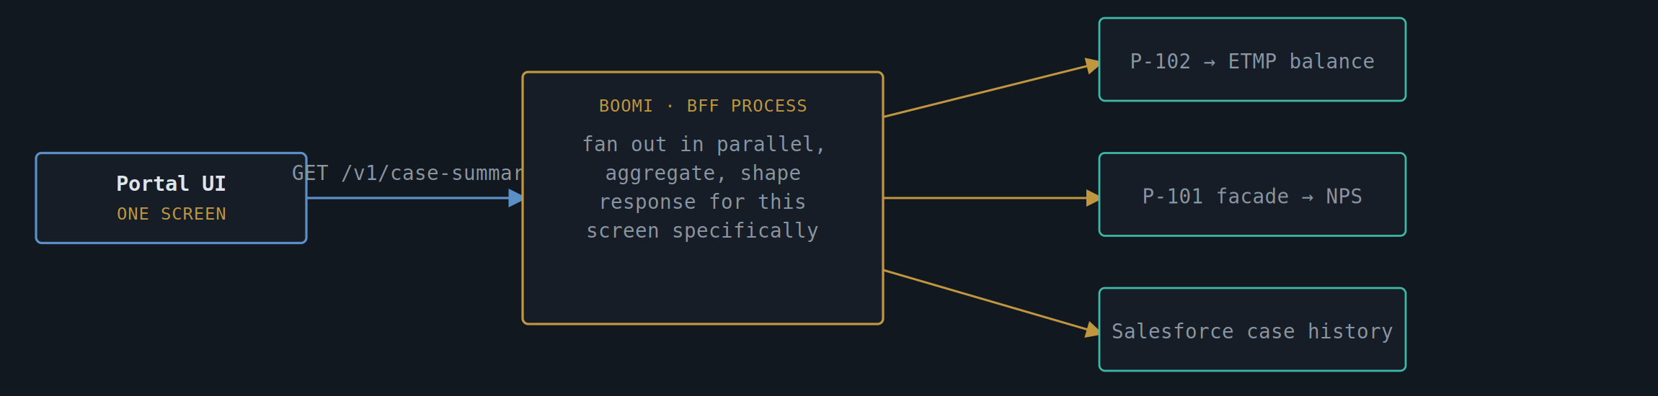
Fig. 11 — One screen-shaped endpoint fanning out to other patterns in this catalogue, composed rather than re-built

Specification
Shape | Response schema is designed around the consuming screen or app, not around any one backend's data model — a true backend-for-frontend, one per channel if channels diverge significantly.
Fan-out | Backend calls issued in parallel inside the Boomi process wherever they're independent; sequential only where one call's result is needed as input to the next.
Partial failure | A non-critical backend timing out (e.g. case history) degrades that section of the response rather than failing the whole aggregate call — degrade gracefully, never block on the least important data.
Caching | Short-TTL cache on the aggregate response for slow-changing sections, keyed by the same correlation/reference ID used elsewhere in the catalogue.
Composition | This pattern is explicitly a composer of others — it calls P-101/P-102 facades rather than reimplementing backend access logic itself.

Notes from the Field
- Keep the BFF thin — it shapes and aggregates, it does not own business logic. Logic that belongs to a domain should live in that domain's own service, not migrate here by convenience.
- One BFF per distinct consuming experience tends to age better than one "generic" aggregation endpoint serving several UIs with subtly different needs.

P-112 · Resilience Guardrail — Circuit Breaker & Bulkhead Isolation
RESILIENCE | FAULT CONTAINMENT | CROSS-CUTTING
Use as a standing guardrail on every outbound connector, not as a one-off fix — a failing or slow backend must be prevented from exhausting Boomi's own connection pool and dragging down every other integration sharing the runtime.
An integration runtime that hosts many processes shares a finite pool of connections and threads across all of them, which means a single backend that starts responding slowly — not even fully failing, just slow — can quietly consume far more than its fair share of that shared capacity. Without protection, that one struggling backend can starve every other integration on the same runtime of the resources it needs, turning a localised problem with one system into an outage affecting everything else that happens to share infrastructure with it. This is one of the most common ways a "small" backend issue becomes a "the whole integration layer is down" incident.
The fix is two complementary techniques applied together as a platform standard, not bolted on per-project. A bulkhead gives every outbound connector its own bounded pool, so backend B running out of capacity simply cannot touch the capacity reserved for backends A and C. A circuit breaker, layered on top, watches the error rate for each backend and trips open once it crosses a threshold — at which point calls to that backend fail immediately and visibly, rather than queuing up behind a system that's clearly already in trouble, with periodic probe calls in a half-open state testing whether it has recovered before traffic is allowed back at full volume.
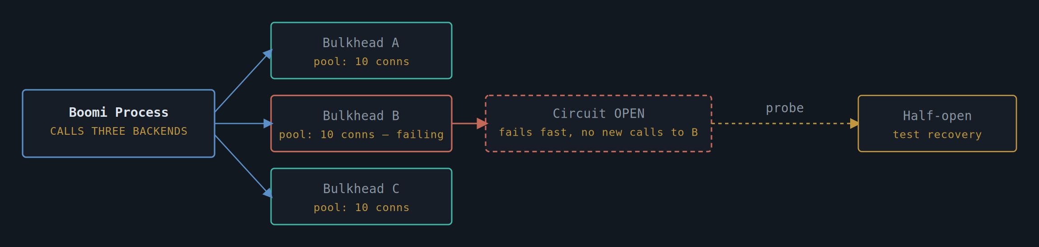
Fig. 12 — Backend B fails inside its own bulkhead; its open circuit cannot starve A or C of connections

Specification
Bulkhead | Each outbound connector gets its own bounded connection pool and thread allocation — one slow backend cannot consume capacity reserved for another.
Circuit states | Closed (normal) → Open (fails fast, no calls reach the backend) → Half-open (a trickle of probe calls tests recovery) → Closed again on success.
Trip threshold | Configured on error-rate over a rolling window (e.g. >50% errors over 20 calls), not on a single failure, to avoid tripping on transient blips.
Fast-fail response | An open circuit returns a clear 503 with Retry-After immediately — never queues calls silently behind a known-bad backend.
Applies to | Every pattern in this catalogue that makes an outbound synchronous call — P-101, P-102, P-105, P-111 in particular.

Notes from the Field
- This is a cross-cutting pattern, not a feature of one integration — apply it as a platform standard at the connector level so individual project teams don't each reinvent (or skip) it.
- Alert on circuit-open events themselves, not just on backend errors — an open circuit is exactly the early warning that prevents a slow degradation becoming an outage.

P-113 · Domain Protection — Canonical Data Model / Anti-Corruption Layer
TRANSLATION | LEGACY INSULATION | GOVERNANCE
Use wherever a legacy system's data shapes and terminology would otherwise leak into every integration that touches it — translate at the boundary, once, instead of letting each new consumer learn the legacy quirks for itself.
Legacy systems accumulate their own vocabulary over decades — terse field codes, status enumerations that made sense to the team that built them thirty years ago, structures shaped by storage constraints that no longer apply. Every new integration built directly against that legacy shape inherits all of it, and every team that builds one has to independently rediscover the same quirks: which field actually means what it sounds like, which status code is deprecated but still appears in old records, which combination of fields is mutually exclusive for reasons nobody currently working on the system remembers. That knowledge, scattered across many integrations rather than centralised in one place, is expensive to maintain and easy to get subtly wrong.
This pattern concentrates that translation work into a single boundary that every other integration sits behind. Boomi defines and owns a canonical data model — a domain-shaped representation that uses sensible names and a structure that reflects the business concept, not the legacy storage format — and exactly one mapping layer per legacy system performs the translation in both directions. Every other consumer, whether it's a new REST facade, an event schema, or a BFF response, is built against the canonical model and never has to learn the legacy system's internal vocabulary at all. The discipline this requires is as much organisational as technical: someone has to own the canonical model and be willing to say no to a consumer who'd rather skip the translation "just this once."
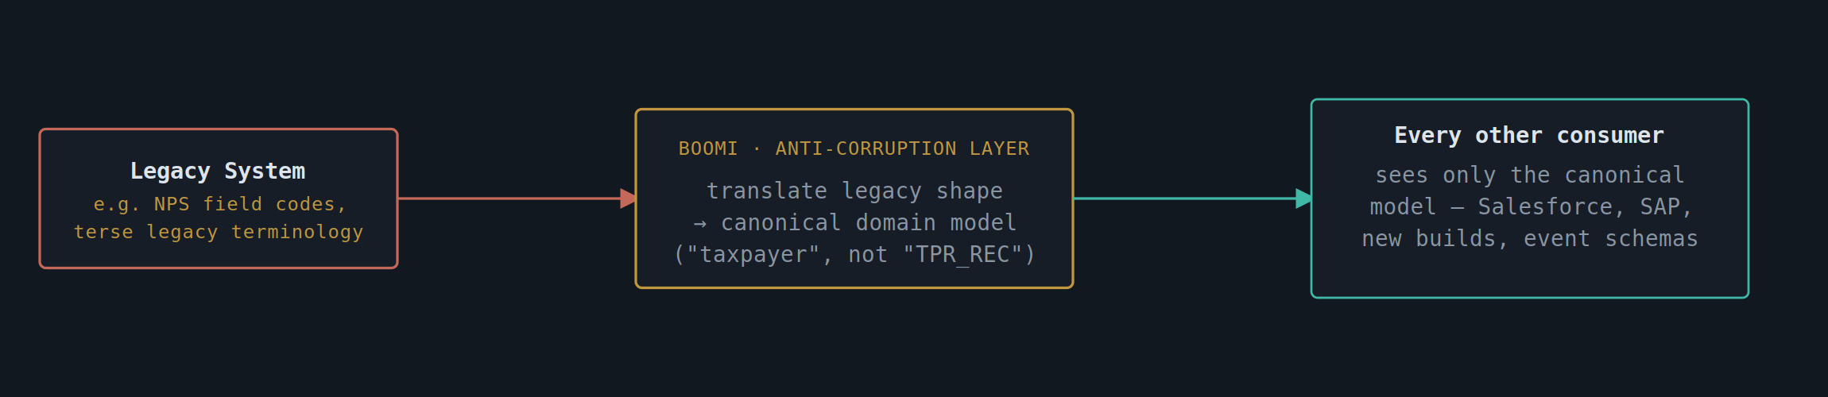
Fig. 13 — One translation boundary; legacy vocabulary never crosses it in either direction

Specification
Canonical model | A domain-owned data model (entities, field names, enumerations) defined independently of any single backend's schema — the model HMRC-facing integrations should have had from the start.
Translation point | Exactly one Boomi mapping layer per legacy system performs the translation; no other process re-implements its own version of the same mapping.
Direction | Applied both inbound (legacy → canonical) and outbound (canonical → legacy) so the legacy system's quirks never appear in canonical-side contracts in either direction.
Versioning | Canonical model versioned independently of the legacy schema — a legacy field rename should not force every downstream consumer to change in lockstep.
Reuse | The same canonical model feeds P-101 facades, P-104 event schemas, and P-111 BFF responses — defined once, used everywhere.

Notes from the Field
- The discipline this pattern requires is organisational as much as technical — someone has to own the canonical model and say no to a consumer who wants "just the raw legacy fields, it's faster."
- Where several legacy systems represent the same real-world concept differently (e.g. two different "case status" enumerations), this is the layer that reconciles them — don't push that reconciliation downstream onto every consumer.

P-114 · Delivery Safety — Idempotent Receiver
EXACTLY-ONCE EFFECT | ASYNCHRONOUS | FINANCIAL SAFETY
Use on every consumer that sits behind an at-least-once delivery mechanism — P-103, P-104, P-108, and P-110 all guarantee a message arrives at least once, never exactly once, so the receiver must make duplicate delivery harmless.
Every asynchronous pattern in this catalogue that involves a queue, a topic, or a relay makes the same honest trade-off: it guarantees a message will arrive at least once, because guaranteeing exactly once across a distributed system in the presence of crashes and network failures is, in the general case, not achievable. A worker can crash after processing a message but before acknowledging it, causing the same message to be redelivered; a webhook retry can succeed on the receiving end while the sender's confirmation is lost, causing it to retry anyway. None of this is a bug in the upstream pattern — it's the expected, designed-for behaviour, and treating a duplicate as a system fault rather than a routine occurrence is a common source of double-charged or double-actioned cases.
The idempotent receiver pattern is what turns "at least once delivery" into "exactly once effect" from the business's point of view. Every message carries a stable identifier — ideally a business-meaningful one, since "this taxpayer's this submission" tends to survive across system boundaries better than an opaque broker-generated ID — and the receiver checks that identifier against a record of what it has already actioned before doing anything that has a real-world effect. A duplicate isn't rejected as an error; it's acknowledged exactly as if it had succeeded, because from the receiver's perspective it already has. This pattern is the quiet, unglamorous half of every reliability guarantee made elsewhere in this catalogue, and it is mandatory wherever a financial or state-changing action sits behind one of those guarantees.
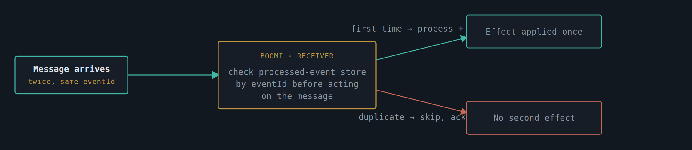
Fig. 14 — Same message arriving twice; the receiver's own record of what it has already done makes the second arrival a no-op

Specification
Dedup key | A stable, message-supplied identifier (event ID, correlation ID, or a business natural key) — never a value the receiver invents itself, or duplicates won't be recognised.
Processed-event store | A lightweight store (table or cache) recording dedup keys already actioned, with a retention window at least as long as the upstream's maximum redelivery window.
Check-then-act ordering | The dedup check and the side-effecting action happen inside the same transactional boundary where possible, to close the race between "checked, not yet recorded" and a near-simultaneous duplicate.
Response to duplicate | Acknowledge the message as successfully processed without repeating the side effect — a duplicate is not an error, it is delivery behaving exactly as designed.

Notes from the Field
- This pattern is the other half of every "at-least-once" promise in this catalogue — treat it as mandatory wherever P-103, P-104, P-108, or P-110 deliver into a system that performs a financial or state-changing action.
- Natural keys are often better dedup keys than generated message IDs in HMRC contexts — "this taxpayer's this submission" tends to be more recognisable across system boundaries than an opaque broker-generated ID.

P-115 · Push Notification — Webhook Push Notification
ASYNCHRONOUS | CALLBACK | CONSUMER-OWNED ENDPOINT
Use when the consumer wants to be told the moment something happens, rather than asking repeatedly — distinct from P-103's polling-friendly correlation model, this pattern pushes to an endpoint the consumer registers up front.
Polling for a result, as in P-103, works well when the consumer is comfortable checking back and the result isn't needed the instant it's ready. Some consumers, particularly internal services that want to react immediately to a change, would rather not poll at all — every poll that comes back empty is wasted load on both sides, and there's an inherent delay between an event happening and the next scheduled poll discovering it. For these consumers, it's more efficient and more responsive for Boomi to push the notification the moment the event occurs, to an endpoint the consumer has registered in advance.
The registration step matters as much as the push itself: a consumer signs up a callback URL and is issued a signing secret that's kept separate from any other credential they hold, and every subsequent callback is signed with that secret so the consumer can verify it genuinely came from Boomi rather than from an attacker who has guessed or discovered the endpoint. Because a network call to an external endpoint can fail for reasons entirely outside Boomi's control, the retry behaviour — exponential backoff, a capped number of attempts, published as part of the API contract rather than left as an implementation detail — is what the consumer actually builds their own resilience around. And because retries mean the same event can arrive more than once, this pattern always pairs with P-114's idempotent receiver on the consuming end; if a consumer's endpoint is down long enough to exhaust retries, a polling fallback ensures they're never permanently blind to the event.
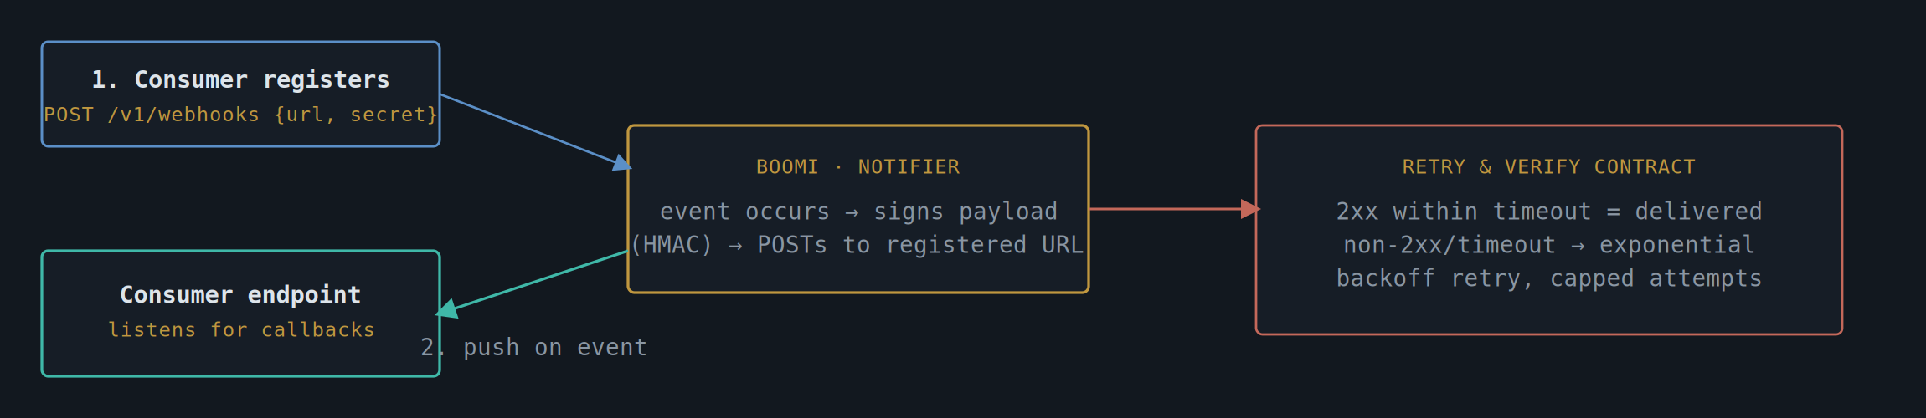
Fig. 15 — Registration once, then push-on-event with signed payloads and a defined retry contract

Specification
Registration | Consumer registers a callback URL and receives a shared signing secret — kept separate from any API key used for other calls.
Payload integrity | Every callback signed (HMAC-SHA256 over the payload) so the consumer can verify it genuinely came from Boomi and was not tampered with in transit.
Retry contract | A non-2xx response or timeout triggers exponential backoff retry up to a published maximum (e.g. 6 attempts over 24h); the contract is documented, not left to be discovered.
Idempotency | Every callback carries an event ID — consumers apply P-114 (Idempotent Receiver) since retries mean the same callback may arrive more than once.
Fallback | If retries exhaust, the event is also queryable via a polling endpoint (P-103-style) so a consumer with a temporarily broken webhook isn't permanently blind to the event.

Notes from the Field
- Publish the retry contract as part of the API documentation, not as an implementation detail — consumers build their own resilience around the numbers in that contract.
- Where a consumer's endpoint is unreliable, this pattern degrades gracefully into something closer to P-103 via the polling fallback — design for that overlap deliberately rather than treating webhook failure as an edge case.

P-116 · Dynamic Routing — Content-Based Router & Scatter-Gather
ROUTING | MULTI-DESTINATION | SYNCHRONOUS OR ASYNC
Use when the destination, or set of destinations, for a message depends on its content — a submission type that must go to one of several regional systems, or a query that must be sent to several and the best answer selected.
Not every routing decision can be made statically at design time. A submission's destination might depend on a case type field, a region code, or a combination of attributes that only becomes known once the message itself has arrived — appeals go one way, standard cases go another, compliance-flagged cases go a third. Hard-coding this kind of decision deep inside an unrelated process, or worse, duplicating the same routing logic in several places, is a reliable way to end up with cases that mysteriously arrive at the wrong system and nobody can immediately explain why.
A content-based router makes that decision explicit, centralised, and inspectable: Boomi examines the relevant fields in the message and applies a declared, version-controlled set of rules to decide where it goes, logging the decision against the message's correlation ID so "why did this end up here" is always answerable after the fact. A message that matches none of the defined rules is never silently dropped — it goes to an explicit default or quarantine path with alerting, because an unrouted message is exactly the kind of failure that should be loud rather than quiet. Where the right destination genuinely isn't known in advance — querying several systems and taking whichever responds first, or with the highest-confidence answer — the scatter-gather variant sends the message to every candidate in parallel and reconciles the responses, trading some extra backend load for either speed or resilience, a trade worth making only once it's confirmed the destinations can absorb being called on every request.
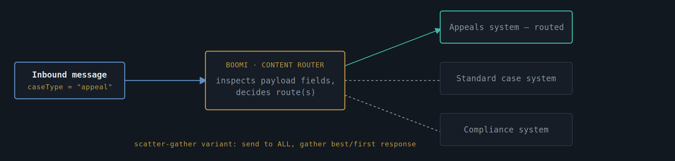
Fig. 16 — Content-based routing picks one path; the scatter-gather variant fans out to several and reconciles the responses

Specification
Routing rule | Decision logic expressed declaratively (e.g. a Boomi Decision shape evaluating payload fields) and version-controlled — routing rules change often enough to need the same review rigour as code.
Scatter-gather | Where the destination isn't known in advance, the message is sent to all candidates in parallel; an aggregation step selects the first valid, fastest, or highest-priority response.
Unmatched content | A message matching no routing rule goes to an explicit default/quarantine path with alerting — never silently dropped.
Auditability | The routing decision taken for each message is logged against its correlation ID, so "why did this go to system X" is answerable after the fact.

Notes from the Field
- Keep routing rules in one place and visible to the people who own the destination systems — routing logic embedded inside an unrelated process is a common source of "why is this case here" investigations.
- Scatter-gather trades extra backend load for resilience or speed; confirm the destinations can absorb being called every time before reaching for it over plain content-based routing.

P-117 · Audience Shaping — Experience API — Entitlement-Based Data Shaping
SYNCHRONOUS | ENTITLEMENT-DRIVEN | DATA GOVERNANCE
Use when one base API holds the full canonical record, but different consumers — partner systems, third-party integrators, internal teams, customer-facing channels — are entitled to see different subsets of it. One model, many views, decided by who's asking.
It's tempting to build a separate API for every consumer that needs a slightly different view of the same data — a partner-facing version, an internal version, a version for a specific third-party integration. In practice this multiplies maintenance burden quickly: the same underlying business object ends up defined and maintained in several places, and a change to the canonical model means hunting down every bespoke variant to keep them all consistent. It also tends to produce inconsistent security enforcement, since each bespoke API implements its own (and sometimes incomplete) idea of what that consumer should and shouldn't see.
This pattern keeps exactly one base API — built against the canonical data model from P-113 — and pushes the variation into a thin entitlement-aware shaping layer in front of it, rather than into multiple base APIs. Every request carries the caller's identity (an OAuth token, an API key, a client certificate identity); Boomi resolves that identity against an entitlement profile that says which fields, which record types, or which specific records that caller may see; and the response is filtered down to exactly that subset before it leaves the platform. The same endpoint, called by two different consumers, can legitimately return two different shapes of the same underlying record — not because there are two APIs, but because there's one API and two entitlement profiles.
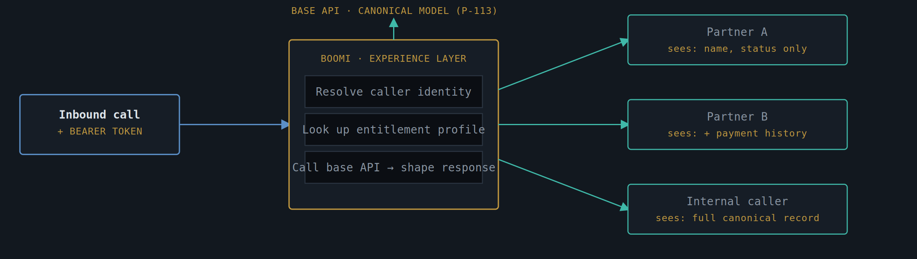
Fig. 17 — One base API and one canonical record; three callers, three entitlement-shaped views of the same data

Specification
Identity resolution | Caller's OAuth token, API key, or client certificate identity resolved to a known consumer at the gateway/API Management layer before the request reaches process logic.
Entitlement profile | A per-consumer (or per-consumer-type) rule set defining which fields, record types, or specific records are visible — held centrally, not hard-coded per endpoint, so a new consumer is an entitlement record, not a code change.
Shaping mechanism | A Boomi Map applied after the base API call, removing or masking fields the resolved entitlement profile doesn't permit — field-level, not just endpoint-level, granularity.
Record-level filtering | Where entitlement restricts which records (not just which fields) a consumer may see, the filter is applied as a query constraint against the base API, not as a post-hoc filter on a full result set, to avoid ever materialising data the consumer isn't entitled to.
Default-deny | An unrecognised consumer or a field with no explicit entitlement rule is excluded from the response by default — entitlement is opt-in per field, never opt-out.
Auditability | Every response logs which entitlement profile was applied and what was filtered, so "why didn't consumer X see field Y" is answerable without reverse-engineering the shaping logic after the fact.

Notes from the Field
- This pattern and P-111 (API Gateway / BFF) solve different problems and are easy to conflate: BFF shapes a response around what one screen needs; this pattern shapes a response around what one consumer is allowed to see. The two compose cleanly — a BFF can sit on top of an experience-shaped base API — but neither substitutes for the other.
- Resist building entitlement logic inside individual integration processes — centralise it once, against the canonical model, so every current and future experience-layer consumer inherits the same enforcement rather than each integration re-implementing its own (and inevitably drifting) version of "what is this caller allowed to see."
- Field-level entitlement is the detail that's easy to skip under delivery pressure and expensive to retrofit — design the canonical model from P-113 with entitlement tagging in mind from the outset, rather than bolting it on after several consumers are already live against an unshaped response.

P-118 · Database Integration — Database Transactions Exposed as a REST API
SYNCHRONOUS | MEDIATION | LEGACY DATABASE
Use when a database holds authoritative transactional data but exposes no service layer of its own — Boomi runs governed, parameterised queries or stored procedures and returns REST/JSON, rather than handing consumers a connection string.
Plenty of long-lived data — reference tables, transaction logs, reconciliation records — lives in a database that was never built with an API in front of it, because at the time it was built nothing outside its own application needed direct access. As soon as a second consumer needs that data, the usual shortcut is to hand out read credentials and let the new consumer write its own SQL against the schema directly. That shortcut works right up until the schema needs to change, at which point every consumer who wrote their own query against the old structure breaks at once, with no contract to tell them it was coming.
This pattern puts Boomi in front of the database instead, in the same spirit as the SOAP-to-REST facade in P-101 : Boomi owns a fixed set of parameterised queries or stored procedure calls, each one deliberately scoped to a specific, named transaction rather than open-ended access to the schema, and returns the result as REST/JSON against a contract that's allowed to stay stable even if the underlying tables change shape. Consumers get exactly the transactions they need, the database gets a single governed entry point instead of an unknown number of direct connections, and a future schema change only requires updating the queries behind the facade rather than chasing down every consumer that wrote raw SQL against it.
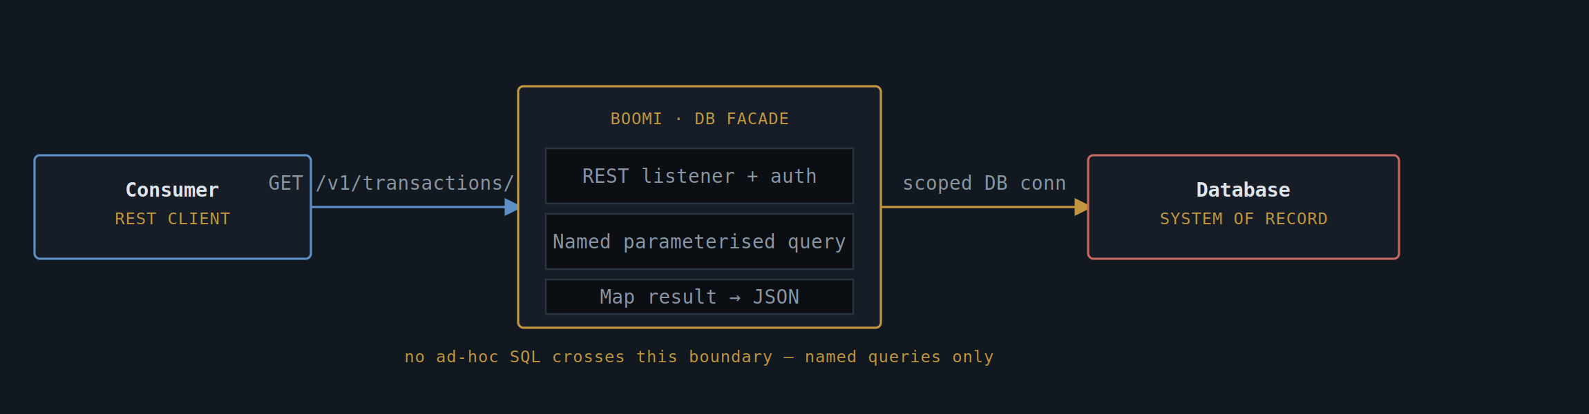
Fig. 18 — Boomi exposes named, parameterised transactions over REST; no consumer ever sees a connection string

Specification
Query scope | Each REST operation maps to exactly one named, parameterised query or stored procedure — never a pass-through that lets the caller supply arbitrary SQL or filter clauses.
Connector | Boomi Database Connector, configured with a service account scoped to only the tables/procedures the exposed transactions actually need — not the application's full database credentials.
Read/write separation | Read transactions and write transactions are modelled as distinct operations with distinct authorisation checks; a consumer entitled to read is never implicitly entitled to write.
Connection management | Connection pooling sized deliberately and isolated per facade (see P-112 Bulkhead) so a spike in REST traffic can't exhaust connections the source application itself depends on.
Schema change handling | The REST contract is versioned independently of the underlying schema — a column rename behind the facade is absorbed in the query mapping, never surfaced as a breaking change to consumers.
Fault handling | Database errors (constraint violations, timeouts, deadlocks) mapped to RFC 7807 problem+json, never surfaced as raw SQL error text to the consumer.

Notes from the Field
- The discipline that makes this pattern work is refusing to add a "generic query" endpoint under pressure — every shortcut of that kind quietly turns this pattern back into direct database access with a REST wrapper around it.
- Where the same database already has several point-to-point consumers with direct access (see P-119 ), this pattern is the migration target — bring consumers across one named transaction at a time rather than attempting a single cutover.
- A service account scoped too broadly is the most common way this pattern's main benefit — containment — quietly erodes; review the account's actual grants against what the exposed queries need, not what's convenient.

P-119 · Database Integration — Direct Database Interaction
HIGH RISK | POINT-TO-POINT | GOVERNANCE REQUIRED
Use only as a deliberate, time-boxed exception — a consumer connects straight to a database's tables with no API contract in between. Every benefit a mediation layer provides (versioning, a security boundary, query governance) is given up in exchange for raw simplicity, and that trade should be made consciously, not by default.
This pattern is documented here because it exists in the estate today, not because it's recommended — and naming it explicitly, with its risks stated plainly, is more useful than leaving it as an undocumented shortcut nobody officially owns. A consumer (an application, a reporting tool, sometimes another integration platform) connects directly to a database's tables using its own credentials and its own SQL, with nothing resembling an API contract, version, or access boundary in between. There's no mediation layer to enforce what the consumer is allowed to see, no contract to absorb a schema change, and no single place to look to understand who currently depends on a given table's exact structure.
The appeal is obvious and the risk compounds quietly: it's the fastest way to get data moving, and it works perfectly well right up until the schema needs to change, at which point every direct consumer is a potential outage with no warning mechanism. Where this pattern is found in the estate, the priority is containment, not necessarily immediate elimination — restrict the credentials to the minimum needed, document who's connecting and why, and treat each instance as a tracked migration candidate toward P-118 rather than a permanent fixture.
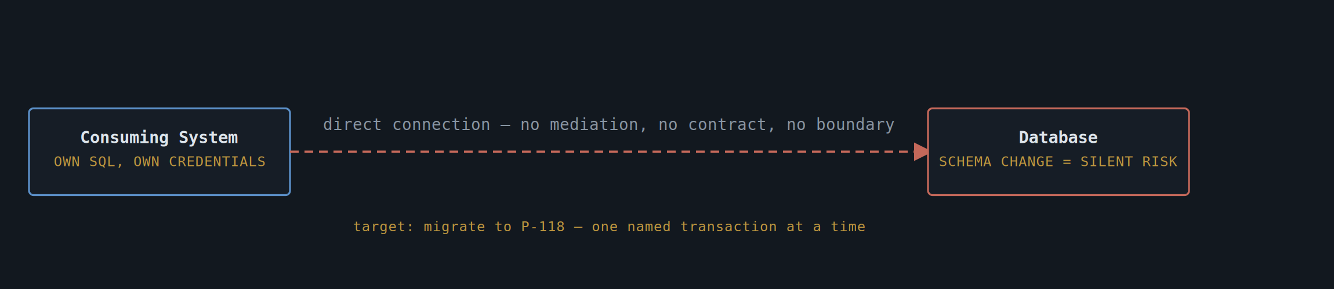
Fig. 19 — No facade, no contract: a schema change on the right is felt directly and without warning on the left

Specification
Typical origin | Usually grows organically — a reporting tool or a second application "just needs a quick read" and direct credentials are issued under delivery pressure, with the intention to formalise it later that rarely happens unprompted.
Risk profile | No contract versioning, no access boundary narrower than the database grants given, and no single inventory of who depends on a given table's structure — schema changes become high-risk by default.
Containment controls | Minimum-privilege credentials (read-only where possible, scoped to specific views rather than base tables), a maintained register of every known direct connection, and a named owner for each one.
Migration path | Each direct connection re-platformed individually onto P-118 — one named, parameterised transaction replacing one piece of ad-hoc SQL — rather than attempting to migrate all consumers in a single change.
Acceptable residual use | Time-boxed, explicitly approved exceptions only — e.g. a short-lived migration script — never a standing integration pattern for new build.

Notes from the Field
- Treat every newly discovered instance of this pattern as a finding to log and schedule, not as a fire to fight immediately — most direct connections have been stable for years precisely because nobody has touched the schema; the risk is real but rarely urgent on its own.
- The honest first step is usually an inventory, not a migration plan — it's common for nobody to currently have a complete list of who holds direct database credentials, and that gap has to close before prioritisation is even possible.
- Resist allowing this pattern to become the default answer for "we need this data quickly" — every instance approved under pressure becomes the next instance someone else points to as precedent.

P-120 · Delivery Confirmation — Acknowledged Subscribe with Retry
ASYNCHRONOUS | CONSUMER ACK/NACK | RETRY & REDELIVERY
Use when receiving a message isn't the same guarantee as successfully processing it — a subscriber explicitly acknowledges only once its own processing has actually completed, so a failure after receipt triggers redelivery rather than silent message loss.
Plenty of "simple consume" integrations quietly assume that once a message reaches the subscriber, the job is done. In practice, receiving a message and successfully acting on it are two different guarantees — a subscriber can receive a message perfectly well and then fail to process it: a downstream call times out, a database write violates a constraint, the worker process crashes halfway through. If the broker considers the message "delivered" the moment it left the queue, none of those processing failures are visible anywhere, and the message is simply gone — not failed, not retried, just lost.
This pattern closes that gap by tying acknowledgment to the outcome of processing, not to receipt. The subscriber only sends an ACK once its own processing has genuinely succeeded; if processing fails, it either sends an explicit NACK to force immediate redelivery, or simply doesn't acknowledge at all, letting the queue's visibility timeout expire and redeliver the message automatically. Either way, the broker — not the subscriber's own bespoke retry code — owns getting the message back in front of a worker, with a bounded number of attempts before it's routed to a dead letter queue for manual review.
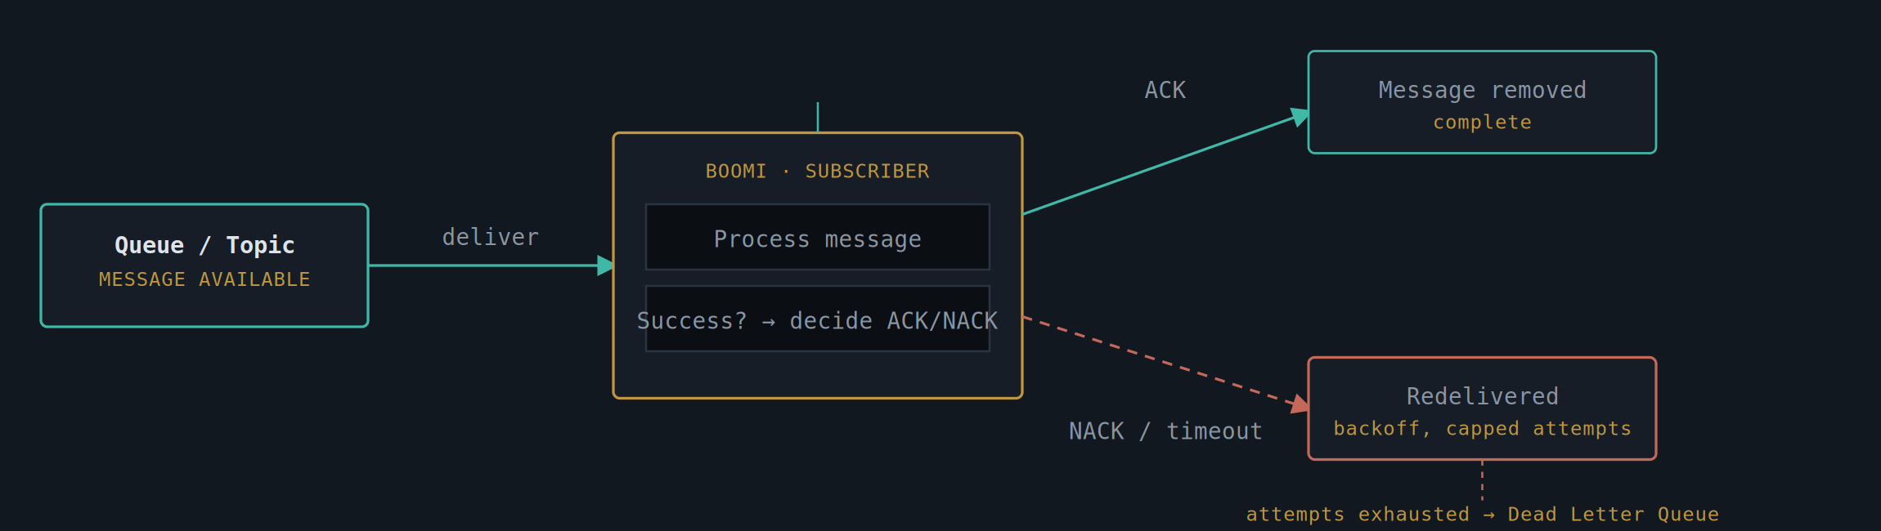
Fig. 20 — ACK only after successful processing; NACK or timeout triggers bounded, backed-off redelivery

Specification
Acknowledgment trigger | ACK sent only after the subscriber's processing logic completes successfully — never at message receipt — so a crash mid-processing leaves the message unacknowledged and eligible for redelivery.
Negative acknowledgment | Where the broker supports it, an explicit NACK forces immediate redelivery rather than waiting out the full visibility timeout — useful when failure is detected quickly and there's no reason to wait.
Retry mechanism | Bounded exponential backoff between redelivery attempts (native to the queue connector's redelivery policy where supported, or a Decision/Branch retry loop otherwise), with a capped attempt count agreed up front.
Visibility / lock duration | Set deliberately longer than the expected processing time, so the message isn't redelivered to a second worker while the first is still legitimately still processing it — avoiding duplicate-in-flight work rather than just duplicate effects.
Dead-letter handling | Exhausted retries route to a Dead Letter Queue carrying the full payload and last failure reason, for manual review rather than silent disappearance.
Idempotency | Because redelivery means the same message may be processed more than once, the subscriber applies P-114 Idempotent Receiver so a duplicate redelivery never double-applies the underlying effect.

Notes from the Field
- This pattern is the formal version of what the as-is "Acknowledged Subscribe" pattern (S5) was already doing informally via a bespoke ACK/reply loop — the broker's native redelivery and backoff replace hand-rolled retry code, and the behaviour becomes documented rather than discovered by reading the process.
- Don't conflate this with P-103 Asynchronous Request-Reply — P-103 is about a caller eventually learning the result of work it initiated; this pattern is about a subscriber's own processing reliability on a message it's already receiving, regardless of who originally cares about the outcome.
- Get the visibility timeout wrong in either direction and this pattern misbehaves in opposite ways: too short, and a slow-but-healthy worker gets its in-flight message redelivered to someone else; too long, and a genuinely failed message sits invisible and unretried for longer than necessary.

P-121 · Delivery Assurance — Reliable Publish with Retry & Guaranteed Delivery
ASYNCHRONOUS | RETRY & BACKOFF | GUARANTEED DELIVERY
Use when a publish failure cannot simply be allowed to drop the message — Boomi retries a failed publish attempt with bounded backoff, tracks its own progress so a crash mid-retry doesn't start over or lose the message, and escalates to a dead letter queue with alerting only once retries are genuinely exhausted.
A plain publish call ( P-104 ) is built around the happy path: the broker is reachable, the call succeeds, the event lands on the topic. In production, that assumption fails more often than the happy-path design admits — a broker connection times out, a network blip drops the call mid-flight, a downstream queue is briefly at capacity. Treated as a one-shot operation, any of these transient conditions simply loses the event, and because publish failures often fail quietly in logs nobody is watching in real time, the gap can go unnoticed until a downstream consumer asks why an expected event never arrived.
This pattern wraps the publish call in the same retry discipline used on the consuming side in P-120 , but applied to the act of publishing itself. A failed attempt is retried with exponential backoff up to a capped number of attempts, with the attempt count and last failure persisted outside the process's own memory so a Boomi Atom restart mid-retry resumes correctly rather than silently abandoning the message. Only once retries are genuinely exhausted does the message move to a dead letter queue, with an explicit alert raised — the difference between a transient blip that quietly self-heals and a sustained outage that needs a human is exactly the distinction this pattern is built to preserve.
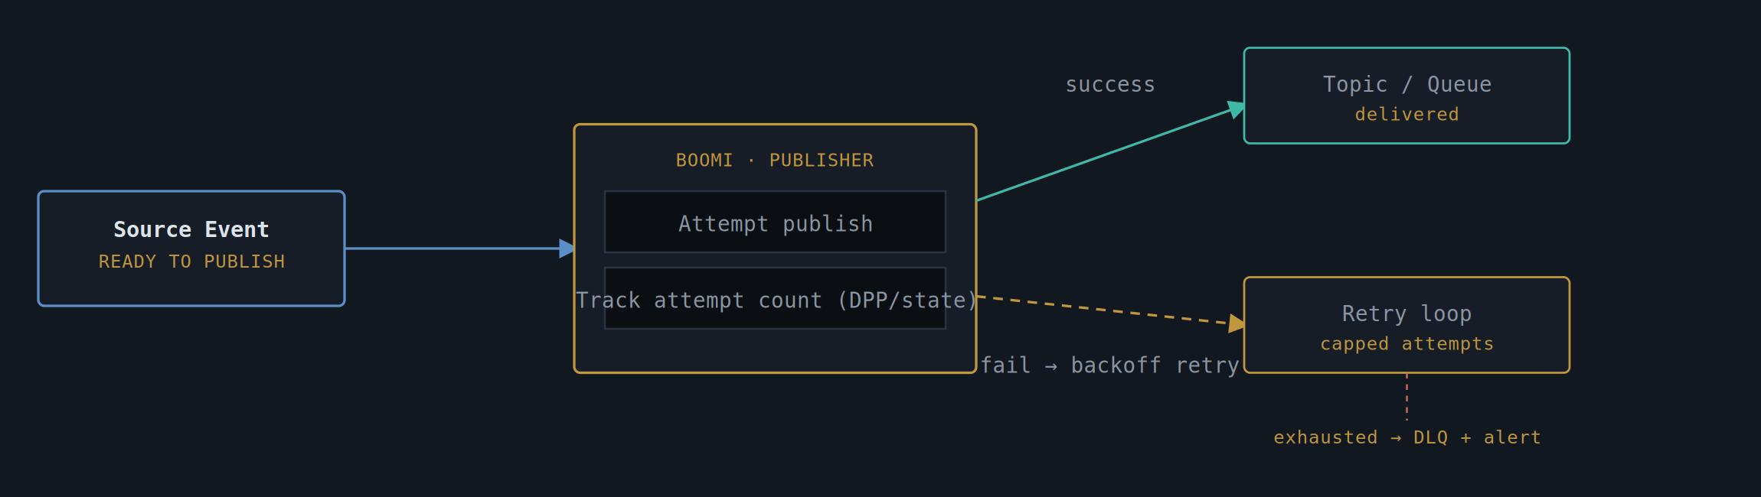
Fig. 21 — A failed publish retries with backoff and persisted attempt state; only exhausted retries escalate to DLQ + alert

Specification
Retry mechanism | Bounded exponential backoff between publish attempts, with a capped attempt count agreed up front — never an unbounded retry loop that masks a sustained outage as ongoing background noise.
State tracking | Attempt count and last failure reason persisted via Dynamic Process Properties backed by a durable store (not just in-memory), so an Atom restart mid-retry resumes from where it left off rather than losing the message or restarting the backoff from zero.
Resilience guardrail | The publish connector sits behind P-112 Circuit Breaker — once a broker is down long enough to trip the breaker, attempts fail fast rather than queuing retries indefinitely against a backend that's clearly not recovering.
Guaranteed attempt | Where the source data change itself must never be silently skipped, this pattern pairs with P-110 Change Data Capture + Outbox — P-110 guarantees a publish is always attempted; this pattern guarantees a failed attempt isn't simply given up on.
Dead-letter handling | Exhausted retries route to a Dead Letter Queue with the full payload and failure history, paired with an explicit Notify/alert shape — escalating to a human only once the pattern's own retry budget has genuinely run out.
Idempotency | Because a retried publish can occasionally succeed on the broker side just as Boomi treats it as failed (an acknowledgement lost in transit), subscribers apply P-114 Idempotent Receiver so an occasional duplicate delivery is harmless.

Notes from the Field
- This pattern formalises what the as-is estate's "Reliable Publish" (P6) and "Publish with Error Handling" (P5) patterns were each doing partially and independently — P5's bespoke Try/Catch-and-alert and P6's hand-rolled retry loop converge into one documented standard here.
- Keep this pattern distinct from P-110 in your own head even though they're often paired: P-110 is about never silently skipping the attempt to publish in the first place (the dual-write problem); this pattern is about what happens when an attempt that was genuinely made then fails.
- Resist the temptation to retry indefinitely "just to be safe" — an uncapped retry loop against a broker that's down for an hour quietly turns into a self-inflicted load problem the moment the broker recovers and every queued retry fires at once.

Pattern Selection Matrix
All sixteen prescriptive patterns, at a glance — style, the situation that calls for it, coupling characteristics, and how failure is handled.
Pattern | Style | Reach for it when… | Coupling | Failure handling
P-101 SOAP-to-REST Facade | Synchronous | A consumer needs REST/JSON but the system of record only speaks SOAP/XML. | Backend WSDL hidden behind a Boomi-owned contract | SOAP Fault → RFC 7807 problem+json
P-102 Synchronous REST Direct | Synchronous | The caller must block for a real-time answer and both ends already speak REST. | Tight — caller waits on the call | Circuit breaker + strict timeout layering
P-103 Async Request–Reply | Asynchronous | The backend is slow or itself async; caller shouldn't hold a connection open. | Loose — correlation ID links the pair | Bounded retry → Dead Letter Queue
P-104 Publish/Subscribe | Asynchronous | One event must reach several independent consumers who can be added freely. | Very loose — publisher unaware of subscribers | Subscriber-owned retry/DLQ, at-least-once
P-105 WebMethods Coexistence Bridge | Bridged (often sync) | WebMethods still owns legacy flows while Boomi takes all new build. | Explicit boundary, mTLS + OAuth2 bridge | Gateway flag → instant rollback to legacy flow
P-106 Saga Orchestration | Asynchronous | One business action spans systems with no shared transaction. | Each step owns a forward + compensating action | Compensation chain runs in reverse on failure
P-107 File-Based MFT | Batch / scheduled | High-volume bulk exchange where per-record APIs don't exist or don't pay off. | Loose — file contract, not a live call | Row-level quarantine, whole-file checksum gate
P-108 Competing Consumers | Asynchronous | Inbound bursts must be smoothed into a steady backend rate. | Loose — workers pull from a shared queue | Poison messages → DLQ after N retries
P-109 Claim Check | Asynchronous (usually) | A message would otherwise carry a large attachment through the broker. | Loose — message carries a reference, not the bytes | Content-hash check on read; orphan-blob sweep
P-110 CDC + Outbox | Asynchronous | A DB write and an event publish about it must never fall out of step. | Atomic at the source DB; relay is at-least-once | Crash-safe — republish never lost, never duplicated logically
P-111 API Gateway / BFF | Synchronous | One screen needs data fanned-in from several backends in one round trip. | Composes other patterns rather than calling backends directly | Degrade non-critical sections, don't block on them
P-112 Circuit Breaker & Bulkhead | Resilience guardrail | Standing protection on every outbound connector — not situational, always-on. | Isolates each backend's failures from every other | Fails fast on open circuit; half-open probes test recovery
P-113 Canonical Data Model / ACL | Translation layer | Legacy data shapes would otherwise leak into every consumer that touches them. | One translation boundary, reused everywhere | Versioned independently of the legacy schema
P-114 Idempotent Receiver | Delivery safety | Sits behind any at-least-once delivery mechanism (P-103/104/108/110). | Receiver-owned dedup, no upstream change needed | Duplicate detected → skip effect, ack only
P-115 Webhook Push Notification | Asynchronous | Consumer wants to be told the moment something happens, not polling for it. | Consumer-registered endpoint, signed payloads | Exponential backoff retry; polling fallback if exhausted
P-116 Content-Based Router / Scatter-Gather | Synchronous or async | Destination(s) for a message depend on its content, not a fixed route. | Routing rules version-controlled and auditable | Unmatched content → explicit quarantine, never silently dropped
P-117 Experience API / Entitlement Shaping | Synchronous | One base API, multiple consumers entitled to different subsets of the same data. | One canonical base API, many entitlement profiles | Default-deny on unrecognised consumer or unrated field
P-118 Database Transactions as REST | Synchronous | A database holds authoritative data but exposes no service layer of its own. | Named, parameterised queries only — no ad-hoc SQL | DB errors mapped to RFC 7807, never raw SQL text
P-119 Direct Database Interaction | Point-to-point | Documented exception found in the estate — not a recommended default for new build. | Tight — no contract, no version, no boundary | Containment + tracked migration to P-118, not immediate cutover
P-120 Acknowledged Subscribe with Retry | Asynchronous | Receiving a message and successfully processing it are different guarantees. | Subscriber-owned ACK/NACK, broker-owned redelivery | Bounded backoff retry → Dead Letter Queue on exhaustion
P-121 Reliable Publish with Retry | Asynchronous | A publish failure cannot simply be allowed to drop the message. | Persisted attempt state, capped backoff retry | Exhausted retries → DLQ + alert, never unbounded retry

Part Two — As-Is Pattern Inventory
The patterns above (P-101 to P-116) are the prescriptive catalogue — the standard this practice designs against. The inventory below is descriptive : it reflects what discovery work has actually found running in the estate today, classified by the shape of each flow's publish, subscribe, or direct-transfer behaviour, with volume and complexity rated per pattern and a count of canonical flows currently mapped against it. Where useful, each row is cross-referenced to the nearest prescriptive pattern, so a migration or rationalisation programme can see at a glance which as-is patterns are already aligned and which represent technical debt to be designed out.
Finding: the single most common pattern observed across the estate is synchronous request/response , predominantly REST or SOAP-based APIs — directly comparable to P-101 (SOAP-to-REST Facade) and P-102 (Synchronous REST Direct) in the prescriptive catalogue above.

Publish Patterns (P1–P8)
Pattern | Name | Description | Vol. | Complexity | Canonicals | Maps to
P1 | Simple Publish | Basic message push, minimal logic | High | Low | 58 | P-104
P2 | Publish with Triggering | Event-driven, poller/scheduler initiated | Medium | Medium | 18 | P-104
P3 | Transforming Publish | Data transformation before publish | High | Medium | 16 | P-104 + P-113
P4 | Validated Publish | Validation before sending | Medium | Medium | 14 | P-104
P5 | Publish with Error Handling | Explicit error handling logic | Medium | Medium | 12 | P-121
P6 | Reliable Publish | Retry, guaranteed delivery, resilience | High | High | 10 | P-110 + P-121
P7 | Transactional Publish | Includes rollback / compensation behaviour | Low | High | 8 | P-106
P8 | Orchestrated Publish | Complex flows, multi-step, multi-system | Low | High | 7 | P-106 + P-116
The eight publish patterns observed form a recognisable maturity ladder — each step adds one further concern (transformation, validation, error handling, reliability, transactionality, orchestration) on top of the one before it. Read as a set, they show a publish layer that grew capability incrementally over time rather than to a single design, which is the normal and expected shape of a long-lived estate rather than a defect in itself; the value of laying them out this way is in seeing clearly which of the more advanced patterns are used sparingly (P7, P8) versus which dominate the volume (P1, P3) when planning where remediation effort will have the most effect.

P1 · Publish — Simple Publish
HIGH VOLUME | LOW COMPLEXITY
The baseline publish shape: a message is pushed outward with no transformation, no validation, and no error handling beyond whatever the underlying connector provides by default. At 58 canonical flows, this is by far the largest single pattern in the estate, which means it is also where the cost of any systemic gap — a missing retry, an absent schema check — is felt the most times across the most flows.
Typical use | Low-stakes notifications and simple data forwarding where the cost of an occasional dropped message is genuinely tolerable.
Risk if unmanaged | At this volume, even a small per-message failure rate compounds into a material number of silently lost messages across the estate.
Prescriptive equivalent | P-104 Publish/Subscribe — but only once delivery guarantees and a versioned schema are added; as found, this pattern is P-104's topology without its discipline.

- Highest-value remediation target by volume alone — a small standard improvement here (schema versioning, basic retry) touches more flows than any other single change in the inventory.
- Worth segmenting before remediating: some of the 58 are genuinely low-stakes and fine as-is, others are quietly load-bearing and have simply never been classified as such.

P2 · Publish — Publish with Triggering
MEDIUM VOLUME | MEDIUM COMPLEXITY
Distinguished from P1 by how the publish is initiated rather than what it does once running: a poller or scheduler decides when the message goes out, rather than the publish firing in direct response to a source-system event. This is a sound, deliberate choice where the source system has no event hook of its own to attach to — but it does mean the publish is only ever as timely as the polling interval, and every poll cycle that finds nothing new is pure overhead.
Typical use | Source systems without native event/webhook support, where polling is the only practical trigger mechanism available.
Risk if unmanaged | Polling interval becomes a hidden latency budget nobody has explicitly signed off on; tightening it to "fix" latency just shifts load onto the source system instead.
Prescriptive equivalent | P-104 Publish/Subscribe, fed by a scheduled trigger rather than a native event source.

- A natural candidate to revisit if the source system later gains genuine event/webhook capability — the publish logic itself usually doesn't need to change, only the trigger.
- Worth confirming the polling interval was a deliberate decision rather than an inherited default nobody has revisited since the integration was first built.

P3 · Publish — Transforming Publish
HIGH VOLUME | MEDIUM COMPLEXITY
Adds a data transformation step ahead of the publish itself — reshaping, renaming, or restructuring the source data before it reaches the topic or queue. At 16 canonical flows and high volume, this is effectively where a de facto canonical model has already started to emerge in the estate, even where no one has formally named or governed it as one.
Typical use | Bridging a source system's native data shape to whatever shape downstream consumers have come to expect.
Risk if unmanaged | Each flow's transformation logic tends to be written independently, so the same underlying mapping decision (e.g. how a status code is rendered) can quietly diverge between flows over time.
Prescriptive equivalent | P-104 combined with P-113 Canonical Data Model — formalising the transformation that's already happening into one governed mapping layer rather than many independent ones.

- Strong candidate for consolidation: comparing the transformation logic across these 16 flows is likely to surface an implicit canonical model worth making explicit.
- The transformation step is also where validation (P4) is most naturally added next, if it isn't already present.

P4 · Publish — Validated Publish
MEDIUM VOLUME | MEDIUM COMPLEXITY
Adds an explicit validation step before the message is sent — checking required fields, value ranges, or referential integrity ahead of publish, rather than letting a malformed message reach the topic and become someone else's problem to detect.
Typical use | Flows where downstream consumers have previously been burned by malformed or incomplete messages and validation was added in response.
Risk if unmanaged | Validation rules defined per-flow rather than centrally tend to drift apart — the same field can be "required" in one flow's validation and optional in another's.
Prescriptive equivalent | P-104 with validation folded into the canonical mapping defined under P-113 , rather than re-implemented per flow.

- A reasonable assumption is that this pattern exists specifically where a past production incident made validation worth the added cost — worth confirming, since that history is useful context for any redesign.

P5 · Publish — Publish with Error Handling
MEDIUM VOLUME | MEDIUM COMPLEXITY
Adds explicit handling for what happens when the publish itself fails — logging, alerting, or routing the failed message somewhere recoverable, rather than letting a publish failure disappear silently. This is the as-is precursor to the retry-and-escalate discipline now formalised as a prescriptive pattern, usually built flow-by-flow rather than as a shared capability.
Typical use | Flows judged important enough that a silently dropped message would eventually surface as a support incident.
Risk if unmanaged | Each flow's error handling tends to be bespoke, so there's no estate-wide view of "what's currently failing and being quietly retried or logged."
Prescriptive equivalent | P-121 Reliable Publish with Retry — the capped backoff, persisted attempt state, and DLQ-plus-alert escalation this pattern was already reaching for informally.

- Centralising error-handling telemetry from these flows into one dashboard is usually low-effort and high-value, since the logic already exists — it just isn't currently visible in one place.

P6 · Publish — Reliable Publish
HIGH VOLUME | HIGH COMPLEXITY
Adds retry and guaranteed-delivery behaviour on top of the publish — the as-is estate's closest equivalent to a proper reliability guarantee, achieved through bespoke retry logic per flow rather than a shared delivery-assurance layer. At high volume and high complexity together, this is one of the more expensive patterns to operate and the most valuable to consolidate.
Typical use | Flows carrying data where loss is genuinely unacceptable — financial or case-critical updates that must not silently disappear.
Risk if unmanaged | Bespoke retry logic, built independently per flow, is exactly where dual-write and duplicate-delivery bugs (the problems P-110 and P-114 exist to solve) tend to hide.
Prescriptive equivalent | P-110 Change Data Capture + Outbox for the never-skip-the-attempt guarantee, paired with P-121 Reliable Publish with Retry for what happens when an attempt that was made then fails — replacing bespoke retry code with the two patterns designed to work together.

- Worth an early audit pass: bespoke "guaranteed delivery" logic is a common place to find it doesn't actually guarantee what the name implies under a true crash-mid-publish scenario.
- High priority for consolidation onto P-110 + P-121 given the combination of high volume and high complexity — this is where operational cost is concentrated.

P7 · Publish — Transactional Publish
LOW VOLUME | HIGH COMPLEXITY
Includes rollback or compensation behaviour directly in the publish flow — if a downstream step fails, this pattern's logic actively undoes what's already been done, rather than leaving it for manual reconciliation. Low in volume but high in complexity, these eight flows are disproportionately important relative to their count, since they're typically protecting the estate's more sensitive cross-system writes.
Typical use | Cross-system writes where an inconsistency between systems would be a genuine business problem, not just a cosmetic one.
Risk if unmanaged | Bespoke compensation logic, written once per flow without a shared pattern to follow, is hard to test thoroughly and easy to get subtly wrong on the failure path specifically — the path least exercised in normal operation.
Prescriptive equivalent | P-106 Saga Orchestration — formalising what these flows are already attempting into the orchestrated, auditable structure the prescriptive pattern defines.

- Despite the low count, each of these eight flows merits individual review — this is where a quiet production data-integrity issue is most likely to be hiding undetected.

P8 · Publish — Orchestrated Publish
LOW VOLUME | HIGH COMPLEXITY
The most complex publish pattern observed: multi-step, multi-system flows where the publish itself is really an orchestrated sequence rather than a single action. At only 7 canonical flows, this pattern is rare by design — it tends to appear only where the underlying business process genuinely has no simpler shape.
Typical use | Business processes that inherently span several systems and several steps, where no simpler pattern could honestly represent what the flow does.
Risk if unmanaged | Complexity concentrated in a small number of flows is easy to under-resource for support and testing, precisely because the low count makes it look like a small concern.
Prescriptive equivalent | P-106 Saga Orchestration combined with P-116 Content-Based Router where the multi-step flow also branches on content.

- Each of these flows is effectively a bespoke saga today — treat re-platforming any one of them as a small project in its own right, not a routine migration item.

Subscribe Patterns (S1–S6)
Pattern | Name | Description | Vol. | Complexity | Canonicals | Maps to
S1 | Simple Consume | Basic message consumption | High | Low | — | P-108
S2 | Transforming Subscribe | Transform data on receipt | Medium | Medium | 5 | P-108 + P-113
S3 | Service-Oriented Subscribe | Triggers business / service logic | High | High | 4 | P-111
S4 | Validated Subscribe | Validation on receipt | Medium | Medium | 4 | P-114
S5 | Acknowledged Subscribe | Requires ACK / reply loop | Medium | High | 3 | P-120
S6 | Orchestrated Subscribe | Multi-step downstream workflows | Low | High | 3 | P-106
The subscribe side mirrors the same maturity progression as publish, but the volumes tell a slightly different story: where simple, low-complexity flows dominate on the publish side, the consume side has a more even spread, with several medium-volume, high-complexity patterns (S3, S5) carrying real operational weight. This is a common asymmetry — publishing is often simpler than correctly consuming, because consumers carry the burden of handling duplicates, ordering, and partial failure that publishers can largely ignore.

S1 · Subscribe — Simple Consume
HIGH VOLUME | LOW COMPLEXITY
The baseline consume shape: a message is read and actioned with no transformation, validation, or duplicate-handling logic beyond whatever the connector provides. As the highest-volume subscribe pattern, this is the pattern most exposed to whatever upstream publish behaviour feeds it — if P1 Simple Publish upstream ever redelivers or drops a message, this pattern has no defence of its own against either outcome.
Typical use | Low-stakes consumption where occasional duplicate processing or an occasional missed message is tolerable.
Risk if unmanaged | No idempotency means any upstream retry or redelivery (deliberate or accidental) has a direct, unguarded effect on this consumer.
Prescriptive equivalent | P-108 Competing Consumers as the target shape, with P-114 Idempotent Receiver added wherever the consumed message has a real-world effect.

- Pair any remediation here with the equivalent work on P1 Simple Publish — the two are very often the two ends of the same flow.

S2 · Subscribe — Transforming Subscribe
MEDIUM VOLUME | MEDIUM COMPLEXITY
Reshapes incoming data on receipt before acting on it — the consume-side mirror of P3 Transforming Publish, and frequently the other half of the same logical mapping, implemented twice rather than once.
Typical use | Adapting a message's published shape to whatever internal model the consuming system actually needs.
Risk if unmanaged | If the publisher's P3 transformation and this consumer's S2 transformation were ever written by different teams at different times, they can encode two different, undocumented assumptions about the same data.
Prescriptive equivalent | P-113 Canonical Data Model — collapsing the publish-side and subscribe-side transformations into one shared, governed mapping.

- Worth checking directly against its corresponding P3 flow for consistency — this is the single most likely place in the estate for two independently-evolved mappings to have quietly diverged.

S3 · Subscribe — Service-Oriented Subscribe
HIGH VOLUME | HIGH COMPLEXITY
Receiving a message here triggers genuine business or service logic — not just a data update, but a process: a calculation, a downstream service call, a state change with real consequences. High volume combined with high complexity makes this one of the more operationally significant patterns in the whole inventory, despite a modest canonical count of 4.
Typical use | Event-triggered business processes — exactly the kind of consumer that needs the protections in P-112 (circuit breaker) and P-114 (idempotency) most.
Risk if unmanaged | Business logic embedded directly in a message handler, without bulkhead isolation, is well-positioned to cause a wider outage if the triggered logic itself misbehaves under load.
Prescriptive equivalent | P-111 API Gateway / BFF where the triggered logic itself calls out to other systems, with P-112 Circuit Breaker applied as a standing guardrail around it.

- Given the combination of high volume and high complexity in only 4 canonical flows, these are strong candidates for individual architectural review rather than batch remediation.

S4 · Subscribe — Validated Subscribe
MEDIUM VOLUME | MEDIUM COMPLEXITY
Validates an incoming message before acting on it — the consume-side equivalent of P4 Validated Publish, and a sign that this consumer has, at some point, been on the receiving end of a malformed message it needed to defend against.
Typical use | Consumers that don't fully trust the publisher's own validation, or that have been burned by a malformed message in the past.
Risk if unmanaged | Duplicated validation logic, defined independently on both the publish and subscribe sides, is a maintenance cost with no corresponding increase in actual coverage if both sides check the same things.
Prescriptive equivalent | P-114 Idempotent Receiver, with structural validation better centralised under P-113 's canonical schema than re-implemented per consumer.

- Compare against the matching publish-side pattern before assuming this validation is redundant — sometimes it's catching genuinely different failure modes from a different point in the pipeline.

S5 · Subscribe — Acknowledged Subscribe
MEDIUM VOLUME | HIGH COMPLEXITY
Requires an explicit acknowledgement or reply back to the sender once the message has been processed — functionally, this is the as-is estate's version of a delivery-confirmation pattern, built as a one-off ACK/reply loop on top of a messaging layer rather than designed as one from the outset.
Typical use | Cases where the broker or sender genuinely needs to know that processing succeeded, not just that the message was delivered to the subscriber.
Risk if unmanaged | An ACK/reply loop built ad hoc, with no formal retry or visibility-timeout discipline, tends to be fragile under failure — exactly the scenario the prescriptive pattern's broker-owned redelivery is designed to handle cleanly.
Prescriptive equivalent | P-120 Acknowledged Subscribe with Retry — the closest like-for-like prescriptive pattern, replacing the bespoke ACK loop with broker-native ACK/NACK and bounded backoff redelivery.

- High complexity at only medium volume suggests these flows are individually intricate rather than uniformly built — worth reviewing each of the three separately before designing a single replacement.

S6 · Subscribe — Orchestrated Subscribe
LOW VOLUME | HIGH COMPLEXITY
Receiving a message here kicks off a multi-step downstream workflow rather than a single action — the consume-side counterpart to P8 Orchestrated Publish, and, like that pattern, rare by nature rather than by oversight.
Typical use | Business processes where a single inbound event needs to fan out into several coordinated downstream steps.
Risk if unmanaged | A multi-step workflow triggered from a message handler, without saga-style compensation, has the same partial-failure exposure as any other unmanaged multi-system write.
Prescriptive equivalent | P-106 Saga Orchestration — these three flows are the most direct as-is evidence that the saga pattern is already needed, just not yet formally applied.

- Good first candidates for a saga-pattern pilot, given there are only three to migrate and each is already known to be business-critical by virtue of its complexity rating.

Direct Patterns (D1–D4)
Pattern | Name | Description | Vol. | Complexity | Canonicals | Maps to
D1 | Simple Direct Transfer | File / batch style movement | Medium | Low | — | P-107
D2 | Scheduled Direct Transfer | Time-triggered batch | Medium | Medium | — | P-107
D3 | Service-Based Direct | Synchronous API | Low | Medium | — | P-102
D4 | Transactional Direct | Strong consistency / rollback | Low | High | 6 | P-106
Direct patterns sit apart from the publish/subscribe families because they describe point-to-point movement — a system or process talking straight to another, with no broker or topic mediating in between. This is the smallest of the three families by pattern count, but it includes both the simplest pattern in the whole inventory (D1) and, with D3 explicitly flagged as undefined, the one genuine evidence gap the discovery exercise surfaced.

D1 · Direct — Simple Direct Transfer
MEDIUM VOLUME | LOW COMPLEXITY
Point-to-point movement of data in a file or batch style, without an intervening broker — one system places data somewhere (a file share, an SFTP drop, a direct database link) and another picks it up, with minimal logic on either side beyond the transfer itself.
Typical use | Simple bulk handoffs between two systems where neither needs anything more sophisticated than "move the file."
Risk if unmanaged | The exact same risks as any unmanaged file transfer — no integrity check, no defined retention, no clear ownership of the file-naming convention.
Prescriptive equivalent | P-107 File-Based Managed File Transfer — wrapping the same basic shape in checksum validation, scheduling discipline, and row-level error handling.

- Low complexity makes this an easy, low-risk pattern to formalise under P-107 early in a remediation programme — quick win, low disruption.

D2 · Direct — Scheduled Direct Transfer
MEDIUM VOLUME | MEDIUM COMPLEXITY
The same point-to-point transfer as D1, but explicitly time-triggered — run nightly, weekly, or on some other fixed schedule rather than ad hoc or on-demand. The added complexity here is almost entirely about schedule management and what happens when a scheduled run is missed or overlaps with the next one.
Typical use | Recurring batch handoffs — reconciliation extracts, nightly syncs — where the timing itself is a meaningful part of the contract.
Risk if unmanaged | A missed or delayed run with no alerting can go unnoticed until a downstream consumer notices stale data, by which point the gap has already had a knock-on effect.
Prescriptive equivalent | P-107 File-Based MFT, with the schedule and run-monitoring formalised as part of the managed transfer rather than left as an external cron job nobody watches closely.

- Worth an explicit audit of what alerting (if any) currently exists for a missed run — this is often the single biggest gap in an otherwise simple pattern.

D3 · Direct — Service-Based Direct
LOW VOLUME | MEDIUM COMPLEXITY
Recorded in the source discovery material as a synchronous, API-based direct call between two systems — but flagged there as incomplete or undefined, meaning the detail needed to describe its actual behaviour with confidence wasn't captured at the time of discovery. This entry is carried forward honestly as a gap rather than filled in with an assumed description.
Typical use | Presumed to be direct synchronous API calls, by analogy with the pattern name — not yet confirmed against actual flow evidence.
Risk if unmanaged | An undefined pattern is itself a risk: it means there are flows in the estate that haven't yet been characterised well enough to assess, migrate, or even count with confidence.
Prescriptive equivalent | Provisionally P-102 Synchronous REST Direct, pending confirmation — this mapping should be treated as a hypothesis to verify, not a finding.

- Recommended next step is a targeted discovery pass specifically on this pattern before any remediation or migration plan relies on it — building a plan on an unconfirmed assumption here carries real risk.

D4 · Direct — Transactional Direct
LOW VOLUME | HIGH COMPLEXITY
Point-to-point transfer with strong consistency or rollback behaviour attached — the direct-transfer equivalent of P7 Transactional Publish, applied where two systems need to stay in lockstep without a broker mediating between them. At 6 canonical flows and the highest complexity rating in the Direct family, these are concentrated, high-stakes integrations.
Typical use | Point-to-point integrations where an inconsistency between the two systems would be a serious, not cosmetic, problem.
Risk if unmanaged | Bespoke rollback logic built directly into a point-to-point integration is hard to test on its failure path and, unlike a broker-mediated saga, has no natural place to make its in-flight state visible to support teams.
Prescriptive equivalent | P-106 Saga Orchestration — formalising the same compensating-action discipline these flows already attempt, with the added benefit of queryable saga state.

- Treat each of the six flows here individually rather than as a batch — high complexity at this volume usually means each one is solving a slightly different problem.

Glossary of Terms
Term | Definition
ETMP | Enterprise Tax Management Platform — a core HMRC system of record referenced throughout the SOAP-to-REST and routing patterns.
NPS | National Insurance and PAYE Service — legacy backend referenced in protocol-bridging examples.
DES / ChRIS | Illustrative case-management and case-engine systems used as the worked example for asynchronous and saga patterns.
TTP / GGIS | Illustrative downstream calculation/processing systems used as event-subscriber examples in the pub/sub pattern.
IF | Illustrative "Integration Framework" downstream consumer used as a pub/sub and MFT target example.
DDC | Illustrative downstream audit/data-capture consumer used as a pub/sub subscriber example.
mTLS | Mutual TLS — both client and server present certificates, used to secure service-to-service bridges (P-101, P-105).
DLQ | Dead Letter Queue — holding area for messages that exhausted their retry budget, used across the asynchronous patterns.
CQRS | Command Query Responsibility Segregation — separating the write model from the read model, related to P-110's outbox approach.
Saga | A sequence of local transactions across systems, each with a compensating action, used in place of a distributed transaction (P-106).
Idempotency | The property that performing an operation more than once has the same effect as performing it once (P-114).
Strangler Fig | A migration approach where new functionality is built around a legacy system until the legacy system can be retired piece by piece (P-105).
Entitlement | A rule defining which fields, record types, or specific records a given consumer is permitted to see, resolved from their identity at call time (P-117).
Experience API | A consumer-facing API layer that shapes a response for a specific audience or access level, sitting in front of a shared base API rather than duplicating it (P-117).
Named Query | A fixed, parameterised database query or stored procedure exposed as a specific transaction, as opposed to open-ended, ad-hoc SQL access (P-118, P-119).
ACK / NACK | Positive/negative acknowledgment a subscriber sends back after processing a message — distinct from message receipt — used by the broker to decide whether to redeliver (P-120).

Document History
Version | Change
1.0 | Initial catalogue — P-101 to P-105: protocol bridging, sync/async, pub-sub, WebMethods coexistence.
1.1 | Added P-106 to P-111 — saga orchestration, MFT batch, competing consumers, claim check, CDC/outbox, API gateway/BFF.
1.2 | Added P-112 to P-116 — circuit breaker/bulkhead, canonical data model/ACL, idempotent receiver, webhook push, content-based routing. Added document control, executive summary, glossary, and this change history.
1.3 | Added elaborate description narrative to all sixteen prescriptive patterns. Added the As-Is Pattern Inventory (P1–P8 Publish, S1–S6 Subscribe, D1–D4 Direct), sourced from architecture discovery, with cross-references to the prescriptive catalogue.
1.4 | Elaborated each of the eighteen As-Is patterns individually — description, specification, and field notes per pattern, including an explicit data gap flagged for D3 (Service-Based Direct).
1.5 | Added P-117 — Experience API / Entitlement-Based Data Shaping: one base API and canonical model, multiple consumers entitled to different subsets of the same data.
1.6 | Added P-118 (Database Transactions Exposed as a REST API) and P-119 (Direct Database Interaction) — the two Database Integration patterns identified in client pattern-discovery work, the latter documented as a contained exception rather than a recommended default.
1.7 | Added P-120 (Acknowledged Subscribe with Retry) — broker-owned ACK/NACK and bounded redelivery, distinct from P-103's caller-initiated request-reply. Remapped as-is pattern S5 from P-103 to P-120 accordingly.
1.8 | Added P-121 (Reliable Publish with Retry & Guaranteed Delivery) — the publish-side counterpart to P-120: capped backoff retry, persisted attempt state, and DLQ-plus-alert escalation. Remapped as-is patterns P5 and P6 from P-114/P-110 to P-121 (and P-110 + P-121) accordingly.

Boomi Integration Patterns — Reference Catalogue, Vol. I · Prepared for internal architecture and delivery use · Pattern codes are an internal reference scheme, not a formal HMRC standard

